Blitzkrieg

Blitzkrieg means ​"lightning war​". Blitzkrieg was first used by the Germans in ​WW2 and was a tactic based on speed and surprise and needed a military force to be based around tank units supported by planes and infantry.​

Blitzkrieg was based on speed, co-ordination and movement. It was designed to hit hard and move on instantly. Its aim was to create panic amongst the civilian population. Doubt, confusion and rumor were sure to paralyze both the ​government and the defending military.​

Stage one​, dive bombers ​were sent in to ‘soften’ up the enemy, destroy all rail lines, communication centers and major rail links.

Stage two​ the German troops moved in using tanks, motorbikes, armored cars were approaching and the planes withdrew only at the last minute so that the ​enemy did not have time to recover their senses when the tanks attacked ​supported by infantry (soldiers) ​ ​ ​ ​ ​
​
1.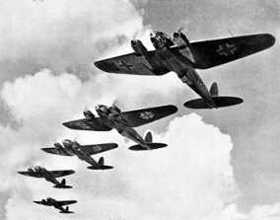
2. 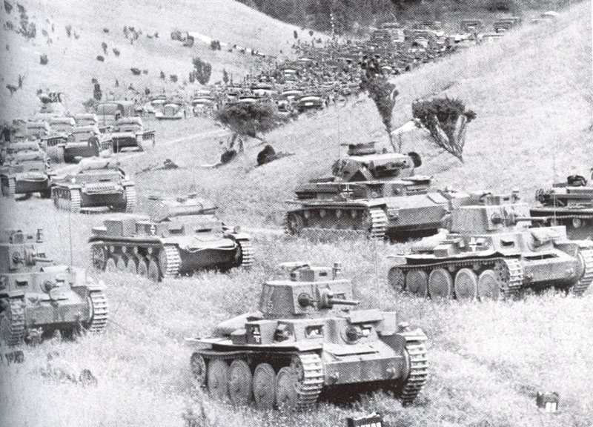 3. 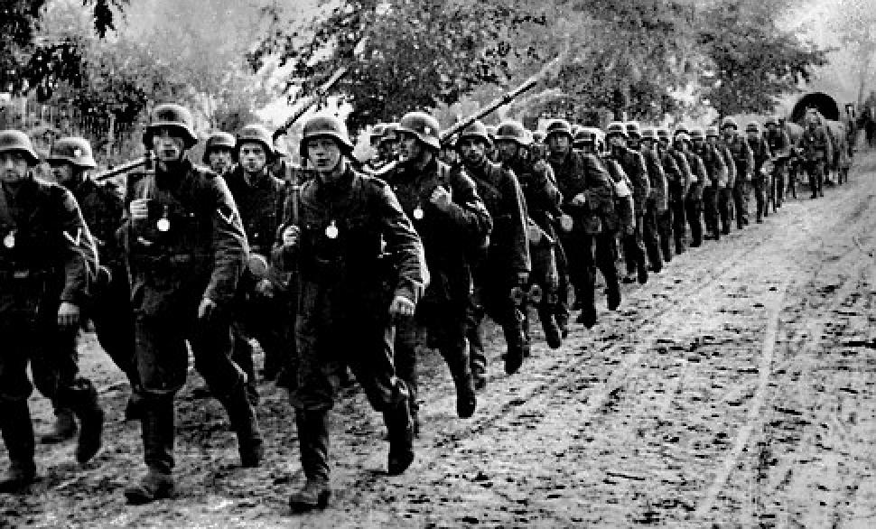

Once a target had been taken, the Germans did not stop to celebrate victory; ​they moved on to the next target. Any civilians fleeing the fighting were also ​attacked to create further mayhem.​

In 1941, a diary kept by an unknown French soldier was found. The diary of the ​attack was written over a period of 5 days. In it are some interesting comments ​that help us understand why this tactic was so successful:​

When the dive-bombers come down, they (the French) stood it for two hours and then ran with their hands over their ears."

"Sedan fell as a result of a bombardment……….it was a superb example of military surprise."

"The pace is too fast……it’s the co-operation between the dive-bombers and the tanks that is winning the war for Germany."

"News that the Germans are in Amiens………this is like some ridiculous nightmare”

In 1940, Britain and France still had a World War One mentality. What tanks they had been poor compared to the Germans. British and French tactics were ​outdated and Britain still had the mentality that as an island it was safe, as the navy would protect them. Nazi Germany realized it had to have a modern military tactic if it was to conquer Europe and give to Germany the territory he wanted for ​the German people.

Questions
1. What was Blitzkrieg? ​

2. Why was Blitzkrieg used? ​

3. Explain stage one of the Blitzkrieg tactic? ​

4. Explain stage two of the Blitzkrieg tactic? ​

5. Using source one explain why Blitzkrieg was so successful? ​

6. Why were the armies of Europe caught so badly prepared by ​this tactic?

