Break the Code:
Renaissance I

Name: ___________________________________________ Date: ______________________ Class Period:

Use this code to help you complete each sentence:
A=1 B=2 C=3 D=4 E=5 F=6 G=7 H=8 I=9 J=10 K=11 L=12 M=13
N=14 O=15 P=16 Q=17 R=18 S=19 T=20 U=21 V=22 W=23 X=24 Y=25 Z=26

1. Renaissance is a French word for 18-5-2-9-18-20-8. ________________________________________________________________________
2. The ancestors of many of today’s musical 9-14-19-20-18-21-13-5-14-20-19, such as the organ, piano, and violin, were invented during the Renaissance. ________________________________________________________________________
3. Michelangelo painted the ceiling of the 19-9-19-20-9-14-5 3-8-1-16-5-12. ________________________________________________________________________
4. During the Renaissance, arts flourished due to the support of 16-1-20-18-15-14-19. ________________________________________________________________________
5. 13-5-4-9-3-9, family that controlled Florence.
________________________________________________________________________
6. The Renaissance began in 9-20-1-12-25. ________________________________________________________________________
7. St. Peters Basilica and the Sistine Chapel are located at the 22-1-20-9-3-1-14
________________________________________________________________________
8. Sculptor whose work includes the Statue of David, 13-9-3-8-5-12-1-14-7-5-12-15 ________________________________________________________________________
9. Painter of the Last Super & the Mona Lisa 4-1-22-9-14-3-9
________________________________________________________________________
10. The Renaissance saw renewed interest in the 3-12-1-19-19-9-3-1-12 culture of ancient Greece and Rome.
________________________________________________________________________
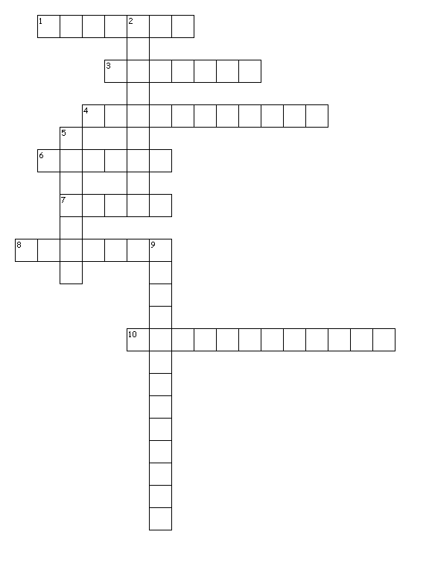

Across Down
1. Home of the Pope 2. Music young people hate
3. He wrote Codes 5. To start over
4. Tools of music 9. His finest work
6. Influential family
7. Home of pasta
8. Fans of art
10. One of the Teenager Mutant Ninja Turtles

