Christianity

Christianity is a monotheistic religion. This means that the followers of this religion believe in one God. The God in Christianity has numerous names: God, Holy Father, and The Holy Trinity to name a few. It is believed that Christianity was founded by Jesus of Nazareth (Jesus Christ) in approximately 33 C.E. Christians believe that Jesus of Nazareth is the son of God. Christians believe that the word of Jesus was the word of God.
Writings from Jesus’s Apostles (First Followers) were compiled into one volume and called the New Testament. Christians use the Bible for their holy scripture. The Bible has two sections: The Old Testament, and the New Testament.
Christianity is divided into numerous sects (Churches with slightly different beliefs). However, the largest and oldest is the Roman Catholic Church. The Apostle Peter in the city of Rome founded the Roman Catholic Church in the present day country of Italy. This headquarters is now known as the Vatican and the Pope, who is considered Gods voice on Earth, runs it.

Approximate Date of Founding- 33 C.E.
Deity- God
Prophet- Jesus of Nazareth (Jesus Christ)
Holy Book- The Bible (The Old Testament & The New Testament)
Major Religious Locations- Jerusalem (Church of the Holy Sepulchre), Bethlehem
Current Head Quarters- Vatican City, Vatican City (Rome, Italy
Current Leader- The Pope (Francis I) for the Roman Catholic Church
Approximate Followers- 2.17 Billion
Percentage of World Followers- 33%
Rank in World Religions- 1
Religious Symbol- The Cross

Christianity

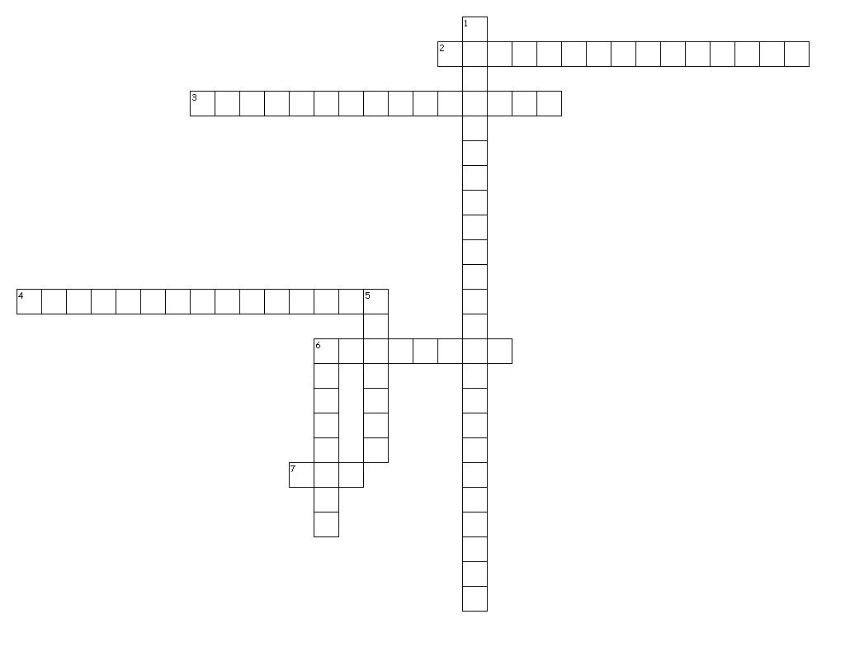
Across 2. 2nd Part of the Bible 3. Prophet 4. 1st Part of the Bible 6. Holy Book 7. Deity Down 1. Major Religious Location 5. Current Leader 6. Religious Symbol

