Islam

Judaism is a religious tradition with origins dating back nearly four thousand years, rooted in the ancient near eastern region of Canaan (which is now Israel and Palestinian territories). Originating as the beliefs and practices of the people known as "Israel," classical, or rabbinic, Judaism did not emerge until the 1st century C.E. Judaism traces its heritage to the covenant God made with Abraham and his lineage — that God would make them a sacred people and give them a holy land.
The primary figures of Israelite culture include the patriarchs Abraham, Isaac, Jacob, and the prophet Moses, who received God's law at Mt. Sinai. Judaism is a tradition grounded in the religious, ethical, and social laws as they are articulated in the Torah — the first five books of the Hebrew Bible. Jews refer to the Bible as the Tanakh, an acronym for the texts of the Torah, Prophets, and Writings. Other sacred texts include the Talmud and Midrash, the rabbinic, legal, and narrative interpretations of the Torah.
The contemporary branches of Judaism differ in their interpretations and applications of these texts. The four main movements within Judaism today are Orthodox, Conservative, Reform, and Reconstructionist, respectively ranging from traditional to liberal to religiously progressive in their application of Torah. While diverse in their views, Jews continue to be unified on the basis of their common connection to a set of sacred narratives expressing their relationship with God as a holy people. Judaism tends to emphasize practice over belief. Jewish worship is centered in synagogues, which completely replaced the Second Temple after its destruction in 70 C.E. Jewish religious leaders are called rabbis, who oversee the many rituals and ceremonies essential to Jewish religious practice.

Approximate Date of Founding- Approx. 2,000 B.C.E.
Deity- Yahweh, Jehovah (God)
Prophet- Moses, Isaac, Abraham
Holy Book- The Torah
Major Religious Locations- Israel, Jerusalem (The Wailing Wall)
Current Head Quarters- None
Current Leader- No Current Global Leader
Approximate Followers- 14 Million
Percentage of World Followers- 21%
Rank in World Religions- 12
Religious Symbol- The Star of David

Judaism

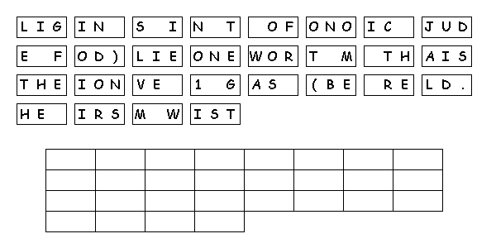
Unscramble the tiles to reveal a message.

