Living Conditions

The prisoners selected for work were housed in wooden or brick built barracks. The brick barracks were constructed in the autumn of 1941. The Germans originally intended the barracks to house 40 prisoners, but very often more than 700 would be placed in each of them. The total number of prisoners to each barrack depended on the number of transports arriving. The prisoners slept in 60 spaces, with three bunks in each space. Prisoners slept on straw spread over the wooden bunks. The barracks had earth floors and few sanitary facilities.
The wooden barracks had once been stables. The walls were thin and had gaps at the bottom and top, which let in the bitterly cold wind. Near the entrance door were two rooms to house the ‘functionaries’ or kapos (heads of the block). The barracks had no windows, but instead had a row of skylights at the top of the roof. Each block had wooden three-tiered bunks. Prisoners slept under thin blankets or rags on mattresses.
Each barrack had two stoves with a brick heating flue running between them. However, fuel was not provided. As a result many prisoners died during the extreme cold of the Polish winters.

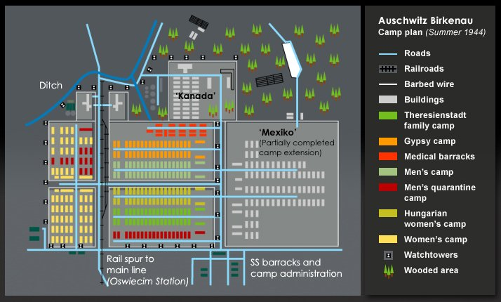
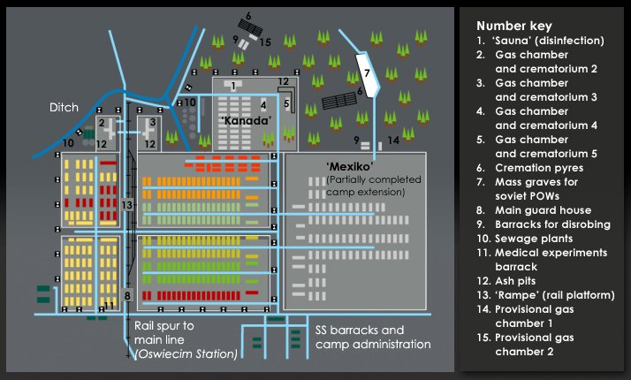

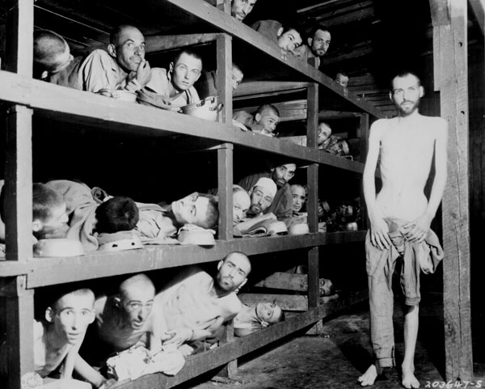

The prisoners slep in 60 spaces, with three bunks in each space. They slept on straw filled mattresses spread over the wooden bunks.
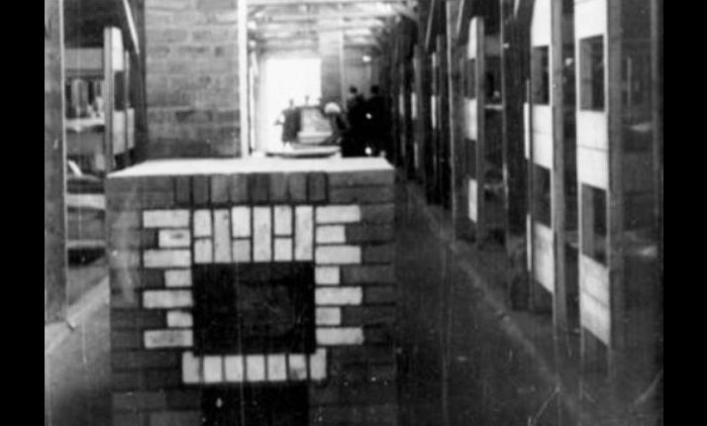
Each wooden barrack had two stoves with a brick-heating flue running between them. However, fuel was not provided. IN the winter the temperature at Auschwitz could reach as low as -4 F. As a result many prisoners froze to death.

