Sanitation

Sanitary facilities for prisoners at Auschwitz-Birkenau were extremely poor. It was impossible for inmates to keep clean or have a change of clothes. For the first two years of the camp’s existence the prisoners had no access to water for washing. When, later, there was water, it was not clean. Prisoners, therefore, spent their existence in the camp dirty and in filthy clothes, which increased the likelihood of them contracting infections and diseases.
Nevertheless, despite the lack of access to clean water, soap and a change of clothes, prisoners continued to go through the motions of washing each morning. This was because, even though it was not possible to carry out the activities of a normal life, it was extremely important to preserve the ‘spirit’ of life, not to give up. This can be seen so vividly in the writings of Primo Levi, a survivor of Auschwitz, who went on to become a distinguished writer,
He remembered having a conversation with a fellow prisoner one morning. He recalled:

“I suddenly see Steinlauf, my friend aged almost fifty, with nude chest, scrub his neck and shoulders with little success (he has no soap) [He] sees me and asks me severely why I do not wash. Why should I wash? Would I be better off than I am? Would I please someone more? Would I live a day longer?…. Does Steinlauf not know that after half an hour with the coal sacks every difference between him and me will have disappeared?….

[Steinlauf says]“…even in this place one can survive, and therefore one must want to survive, to tell the story, to bear witness; and that to survive we must force ourselves to save at least the skeleton, the scaffolding, the form of civilisation.

“We are slaves, deprived of every right, exposed to every insult, condemned to certain death, but… … we must certainly wash our faces without soap in dirty water and dry ourselves on our jackets.... ...for dignity... We must walk erect, without dragging our feet... ...to remain alive, not to begin to die.”
– Primo Levi, “Survival in Auschwitz”
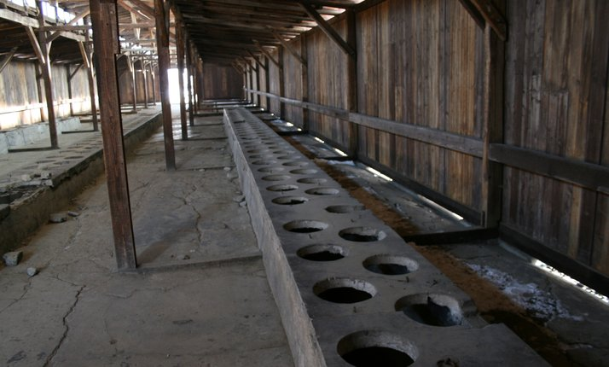
Remains of the toilets at Auschwitz

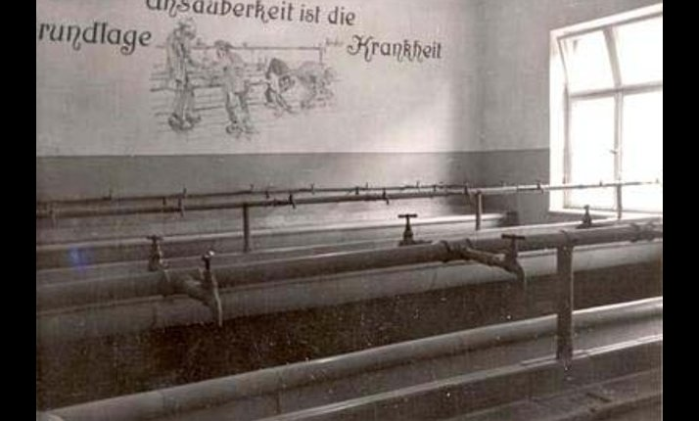
Washbasins in a prisoner’s sanitation block during 1941. You can see the German messages telling the prisoners that they must was to keep clean and healthy. However, clean water was rarely supplied.

