The Fall of Rome & the Dark Ages
1 A Day
Alexander Heilig
Pear Deck - September 6, 2019 at 8:18AM

Part 1 - Summary
Use this space to summarize your thoughts on the lesson

Part 2 - Responses
Slide 1
Use this space to take notes:

Slide 2
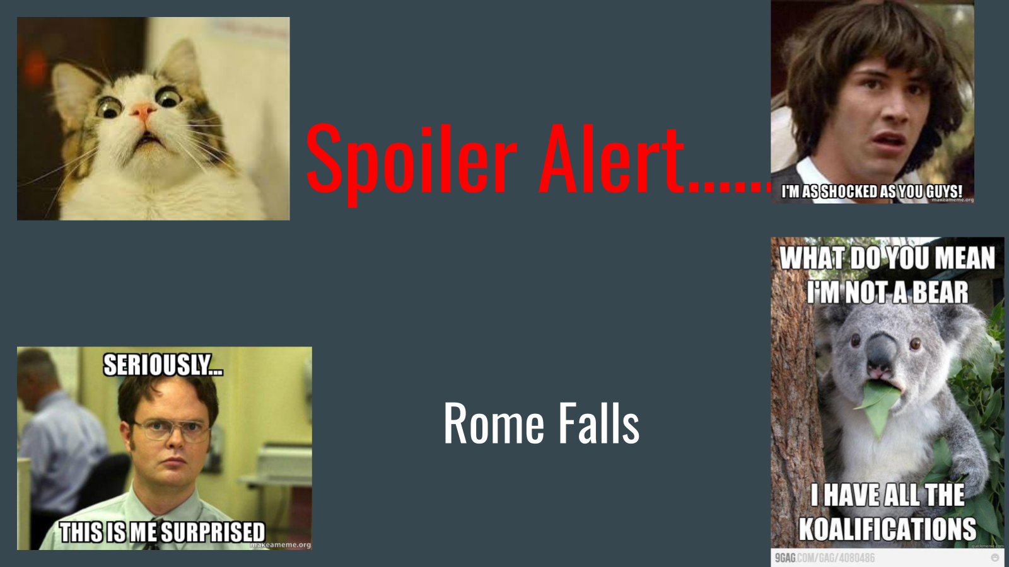

Use this space to take notes:

Slide 3
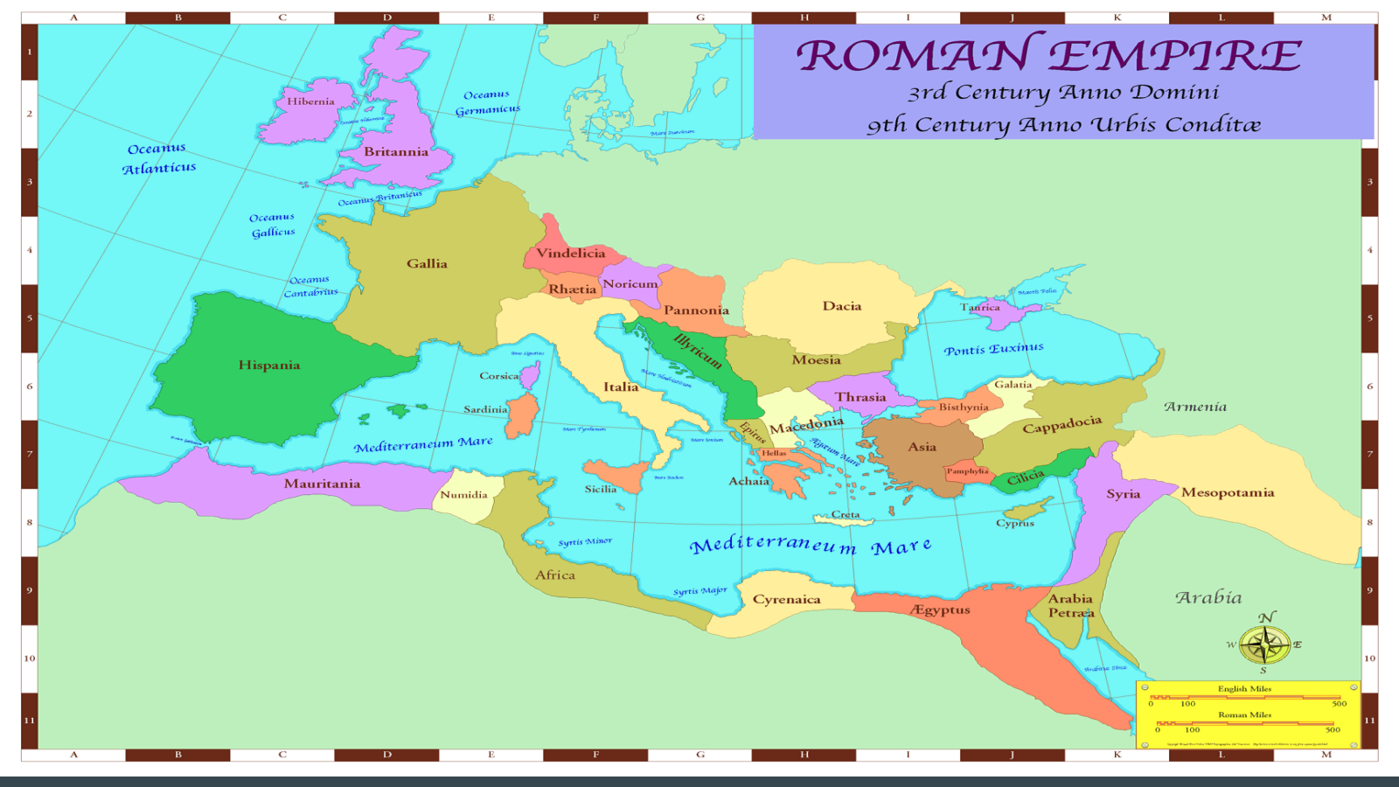

Use this space to take notes:

Slide 4 | Your Response
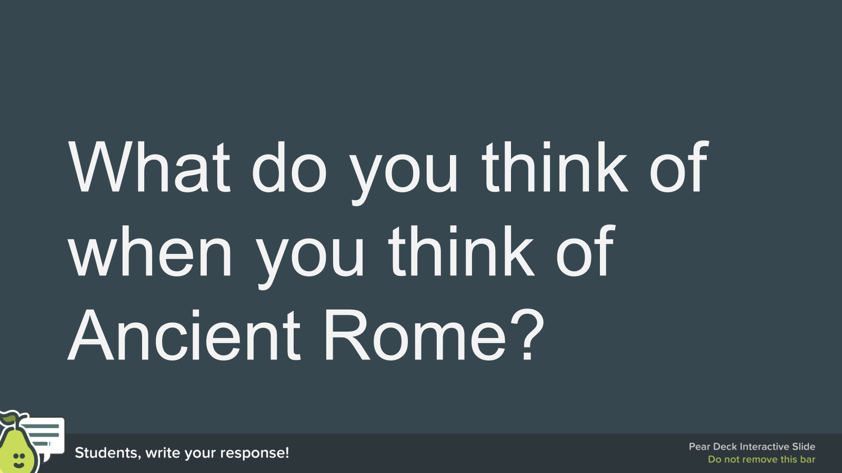
Use this space to take notes:

Slide 5
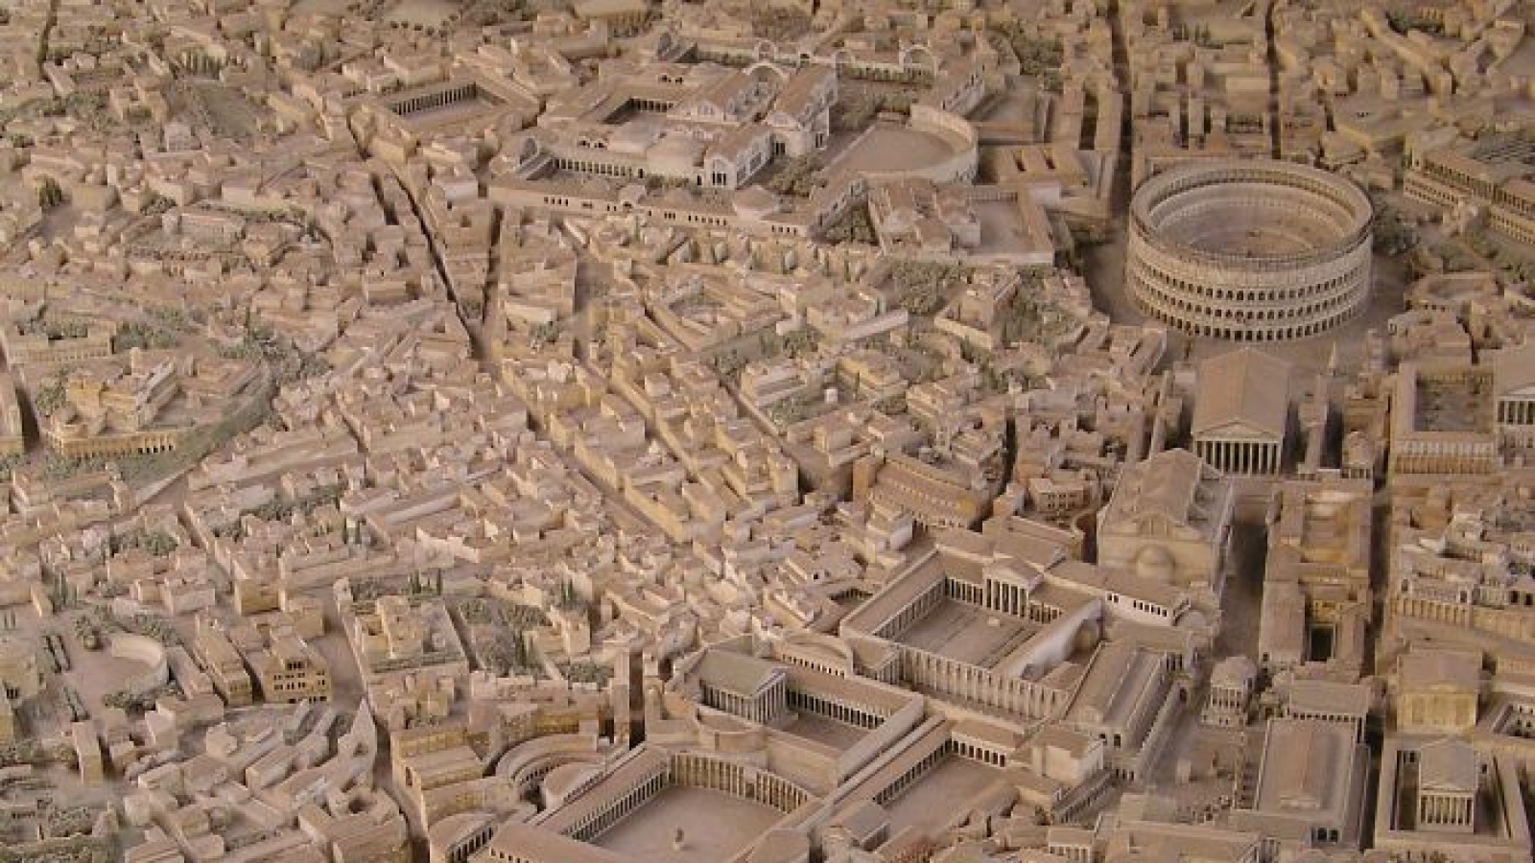

Use this space to take notes:

Slide 6
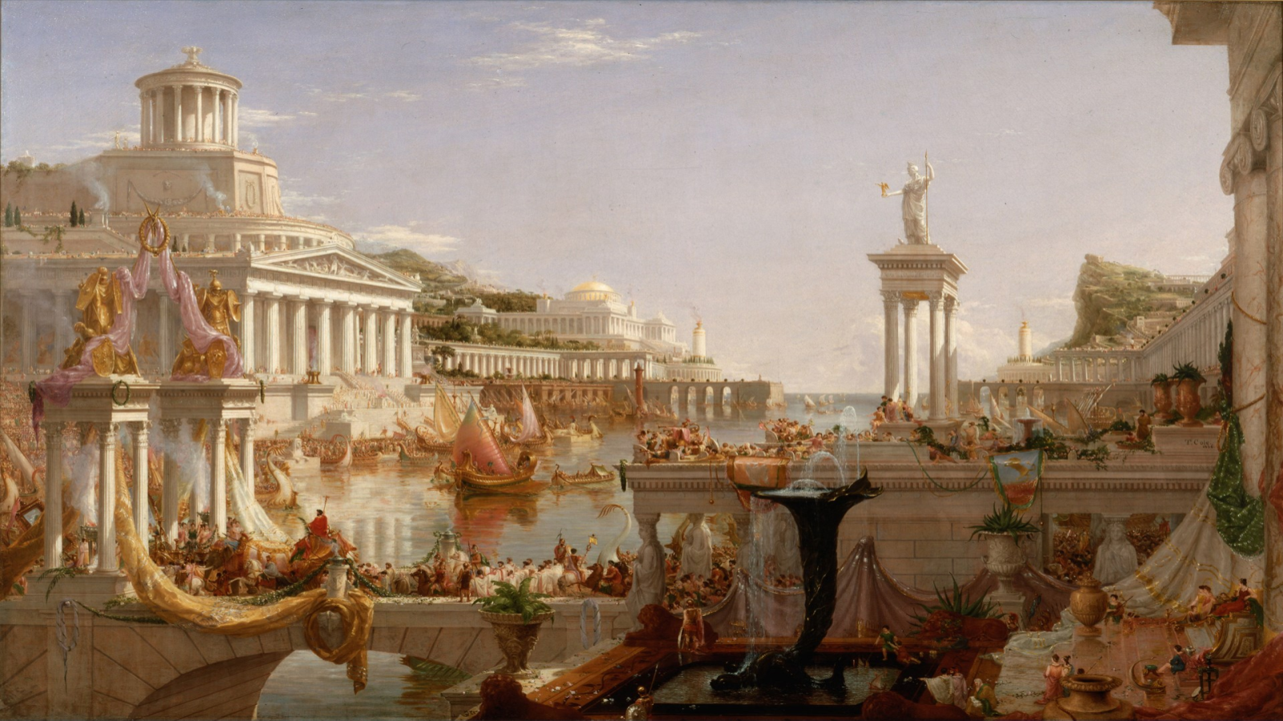

Use this space to take notes:

Slide 7
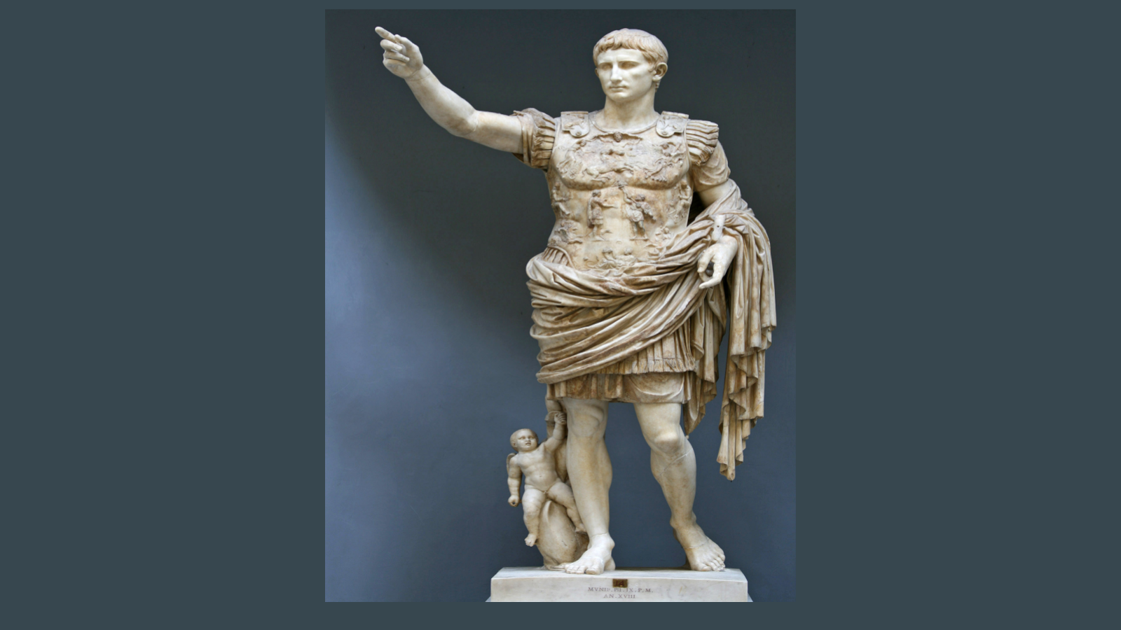

Use this space to take notes:

Slide 8
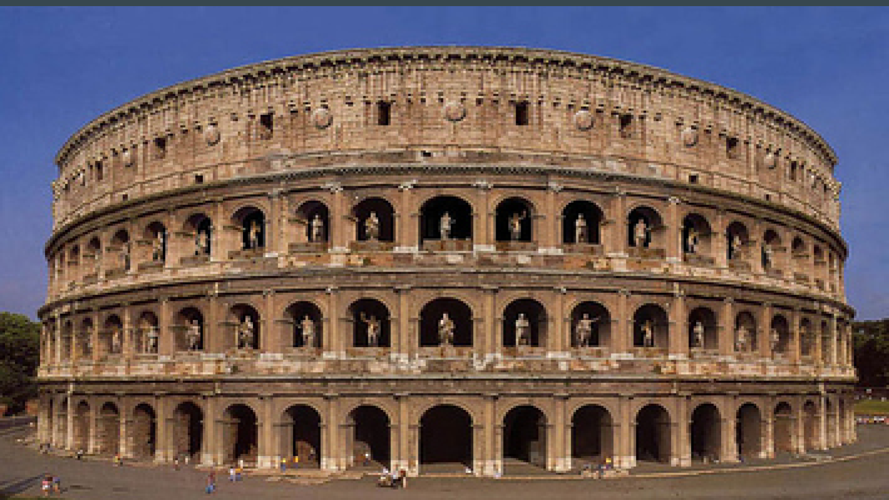

Use this space to take notes:

Slide 9
Use this space to take notes:

Slide 10
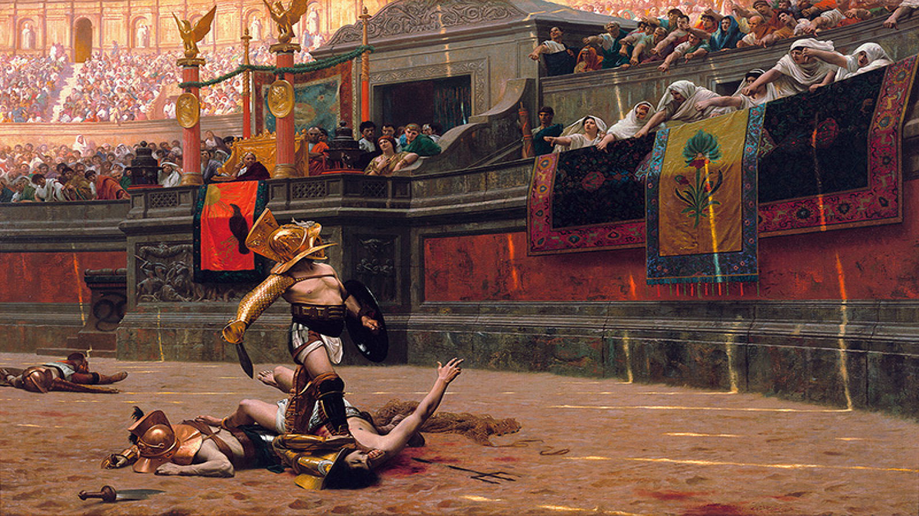

Use this space to take notes:

Slide 11 | Your Response
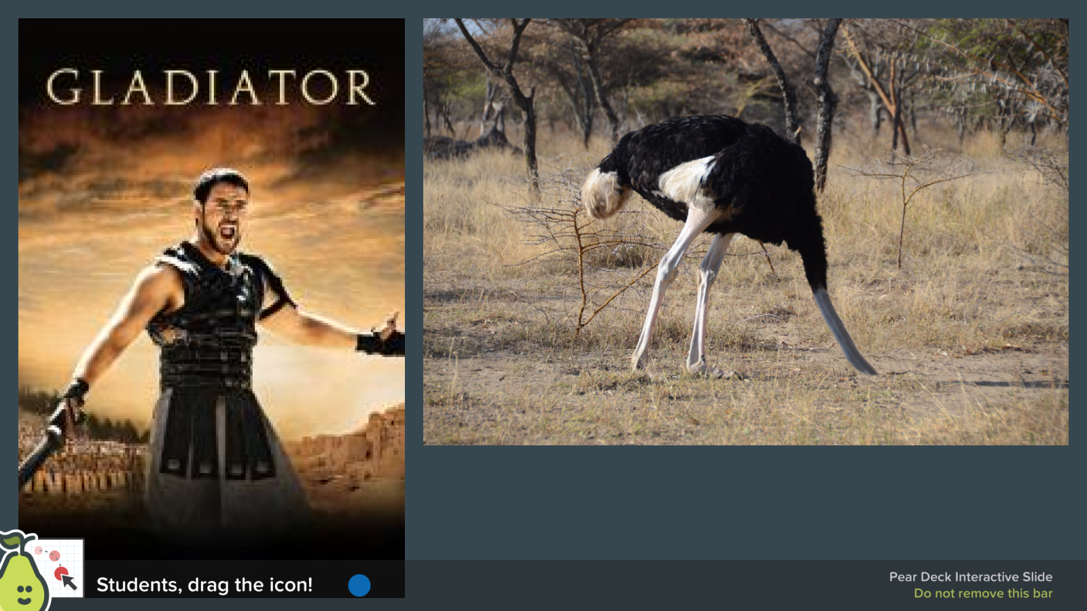
Use this space to take notes:

Slide 12
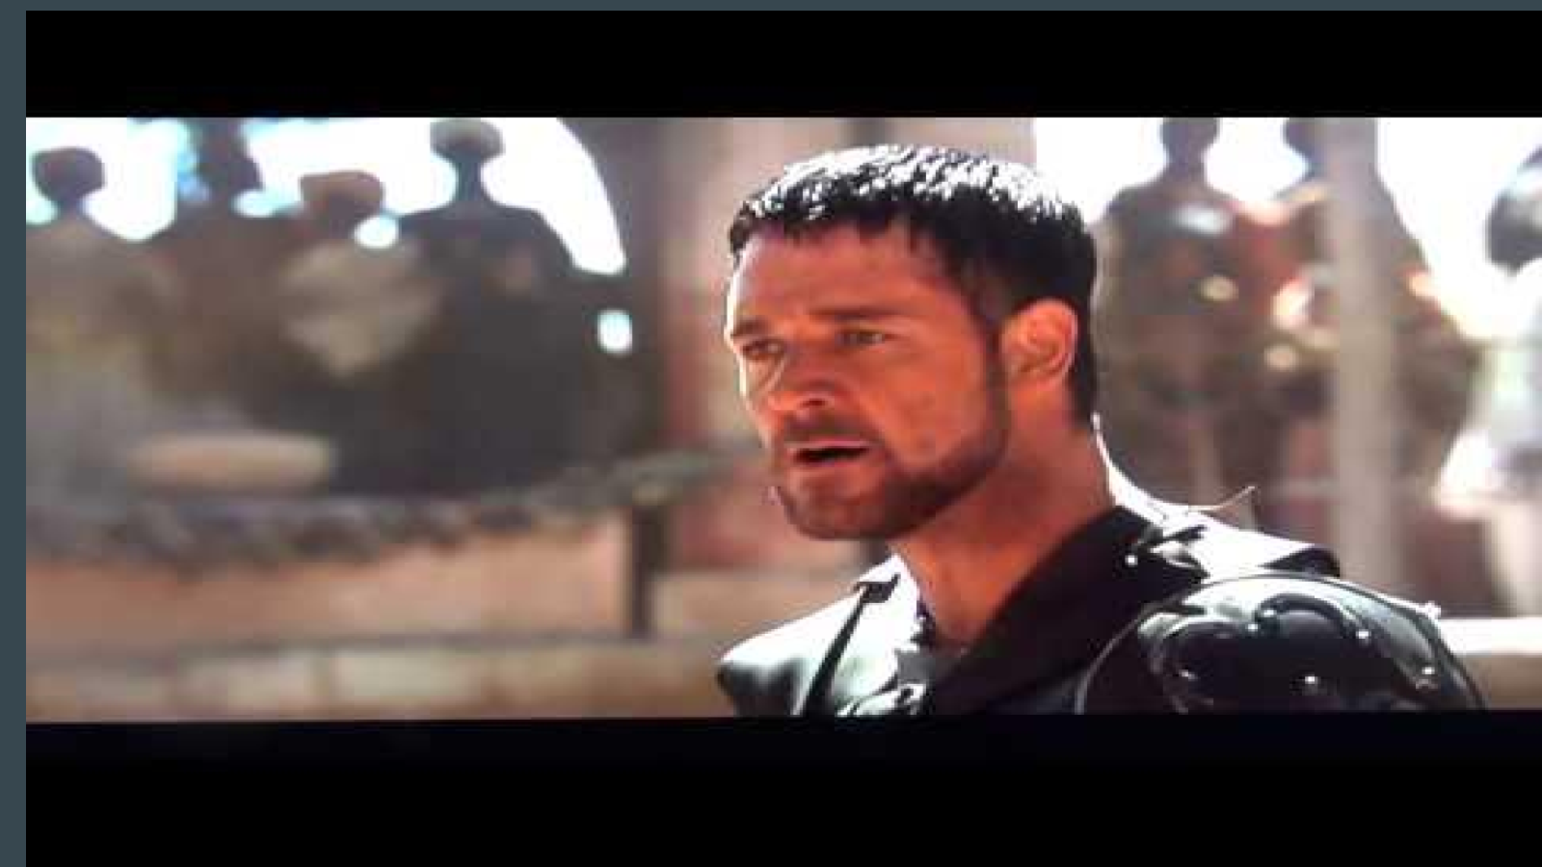

Link(s) on this slide:
- http://www.youtube.com/watch?v=xMVLwl35R_I

Use this space to take notes:

Slide 13
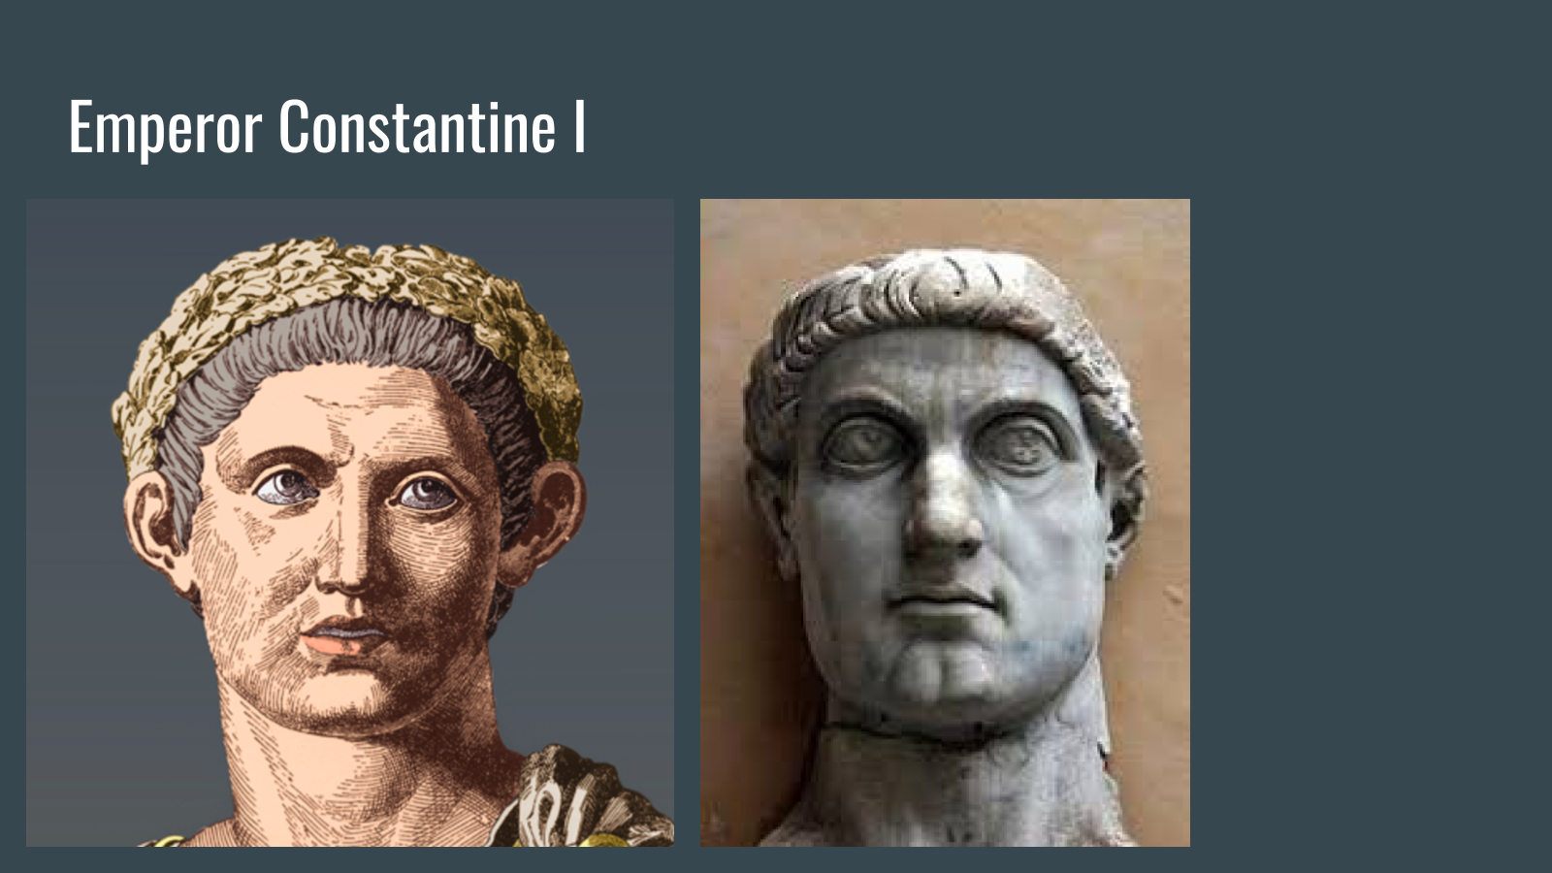

Use this space to take notes:

Slide 14
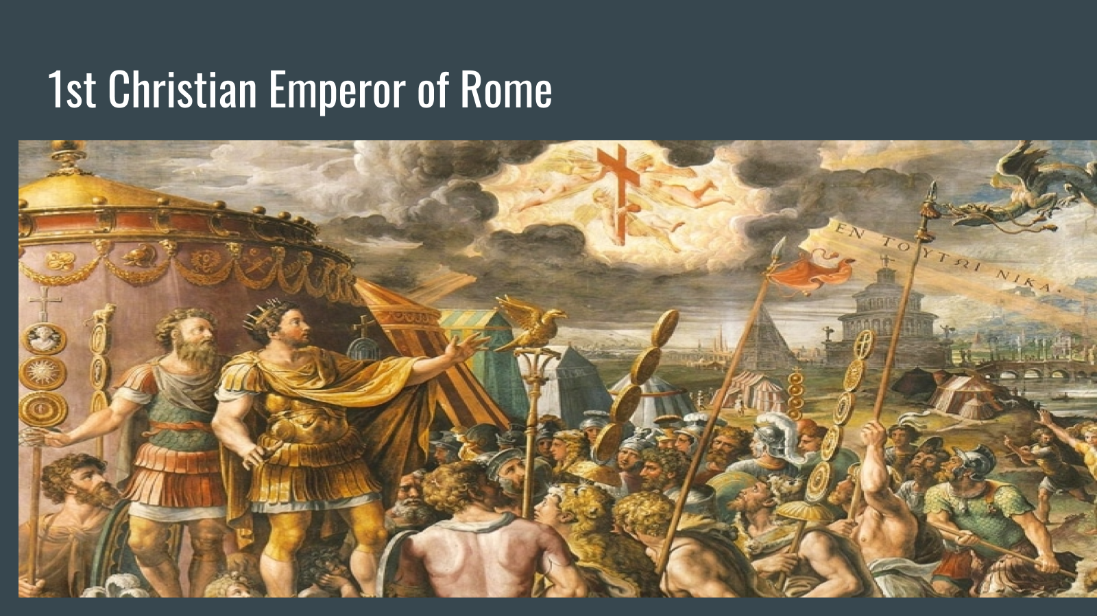

Use this space to take notes:

Slide 15 | Your Response
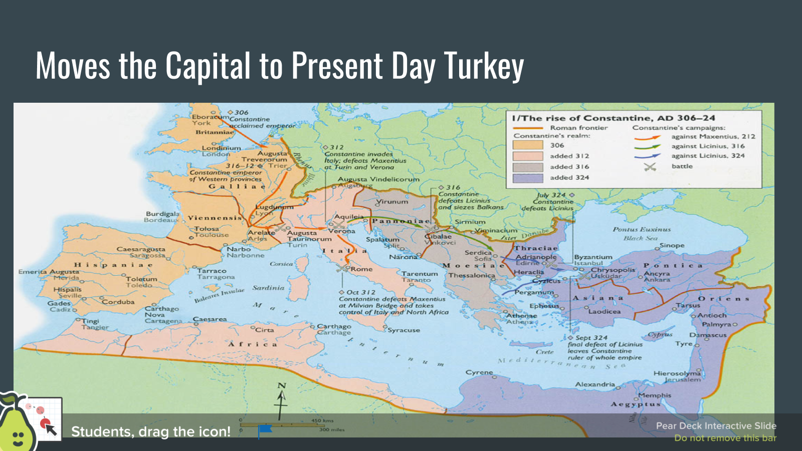
Use this space to take notes:

Slide 16
Use this space to take notes:

Slide 17
Use this space to take notes:

Slide 18
Use this space to take notes:

Slide 19 | Your Response
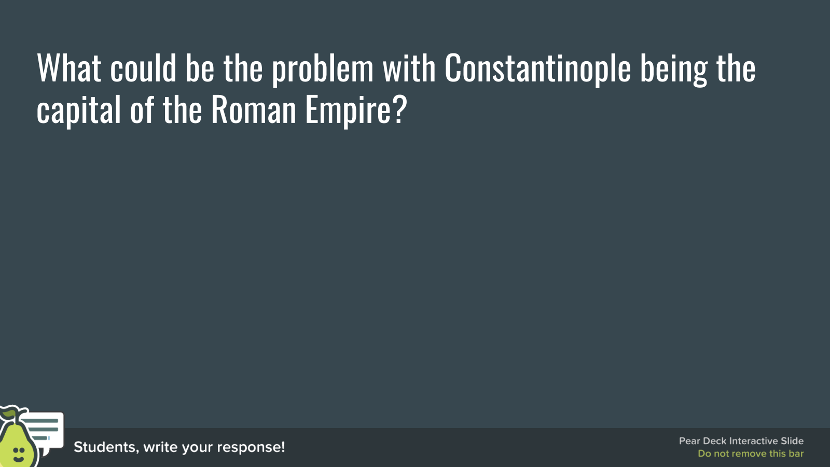
Use this space to take notes:

Slide 20
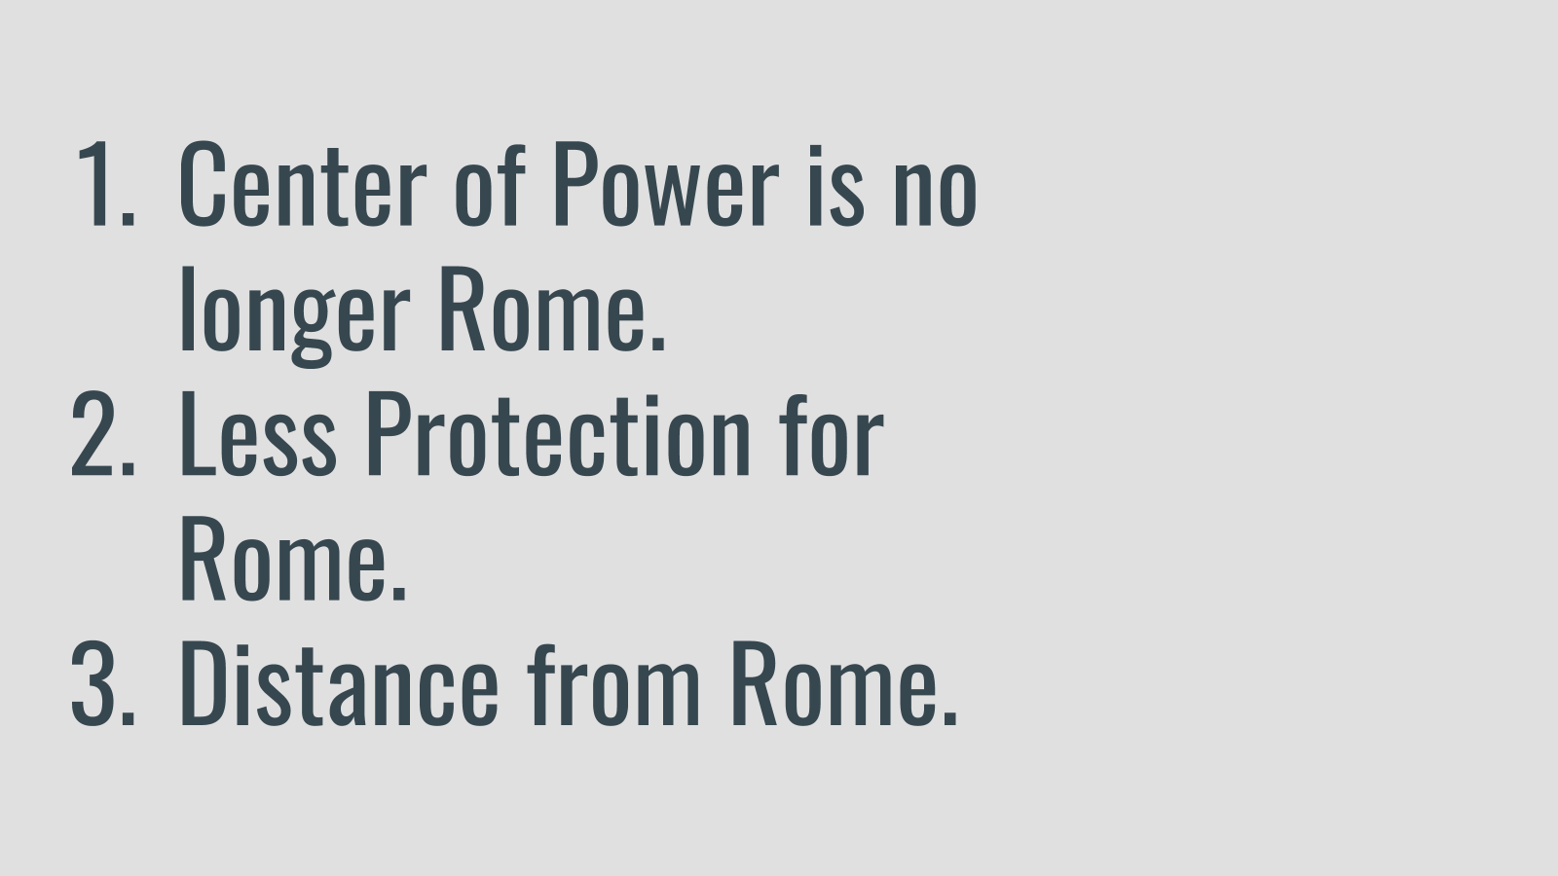

Use this space to take notes:

Slide 21
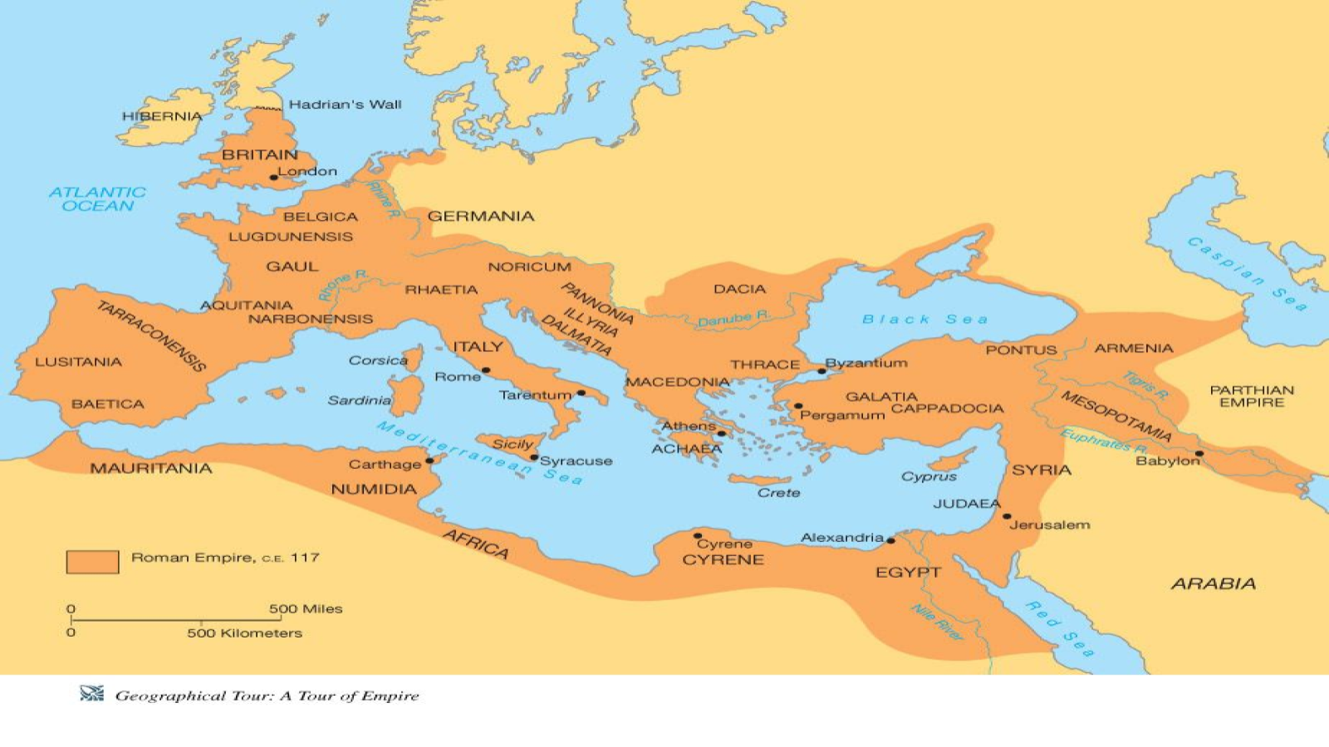

Use this space to take notes:

Slide 22
Use this space to take notes:

Slide 23
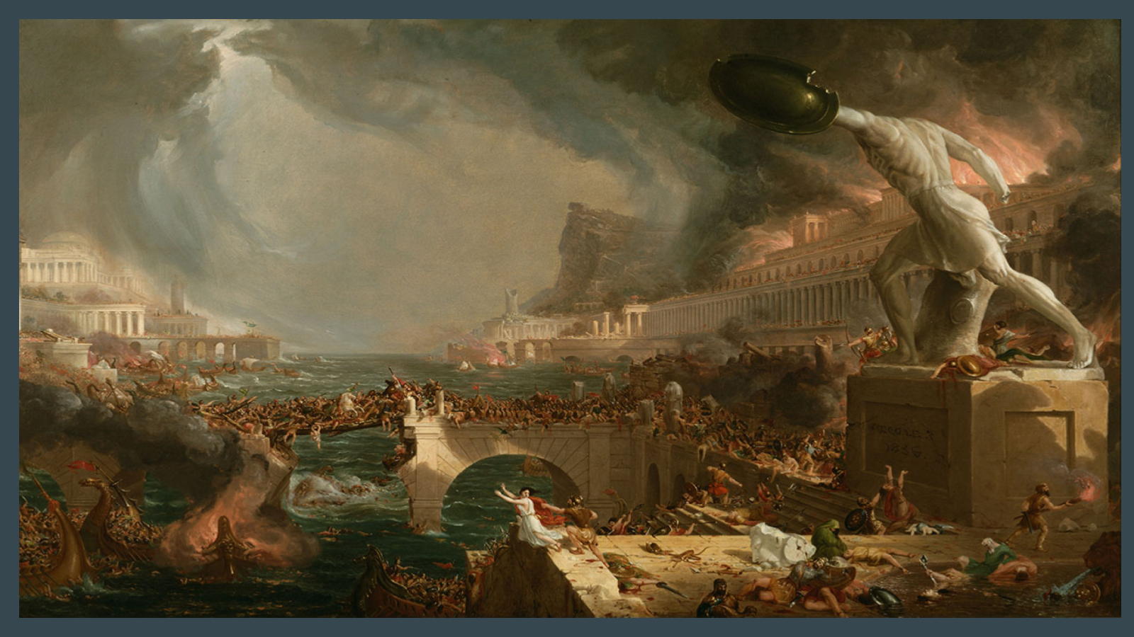

Use this space to take notes:

Slide 24 | Your Response
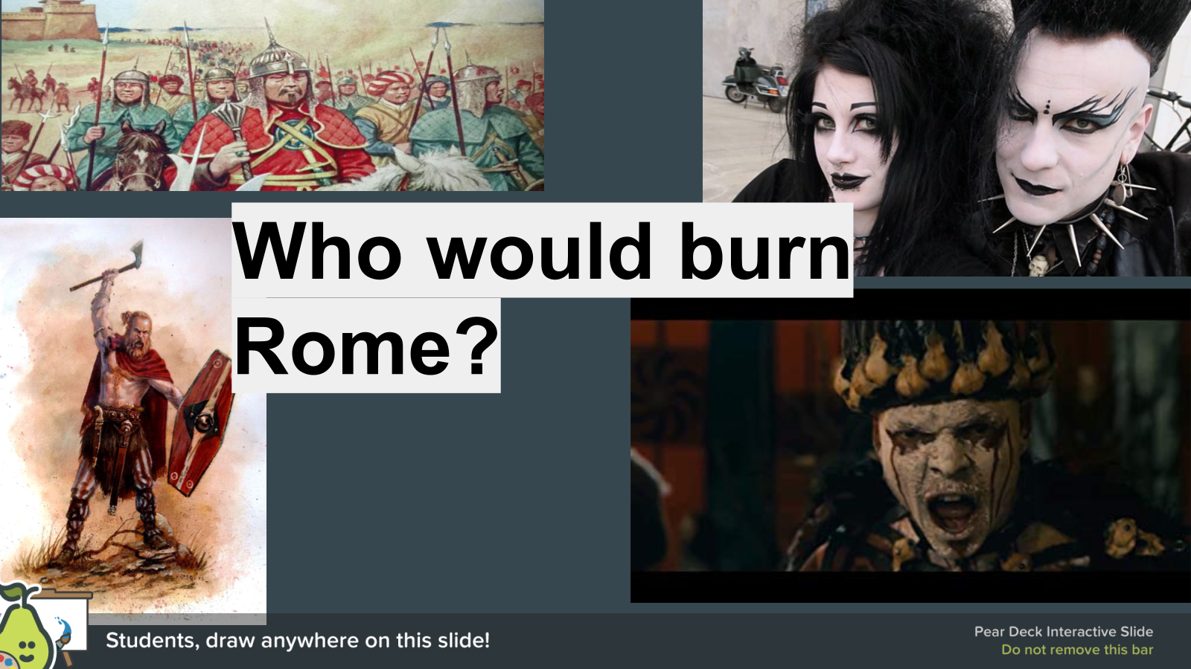
Use this space to take notes:

Slide 25
Use this space to take notes:

Slide 26
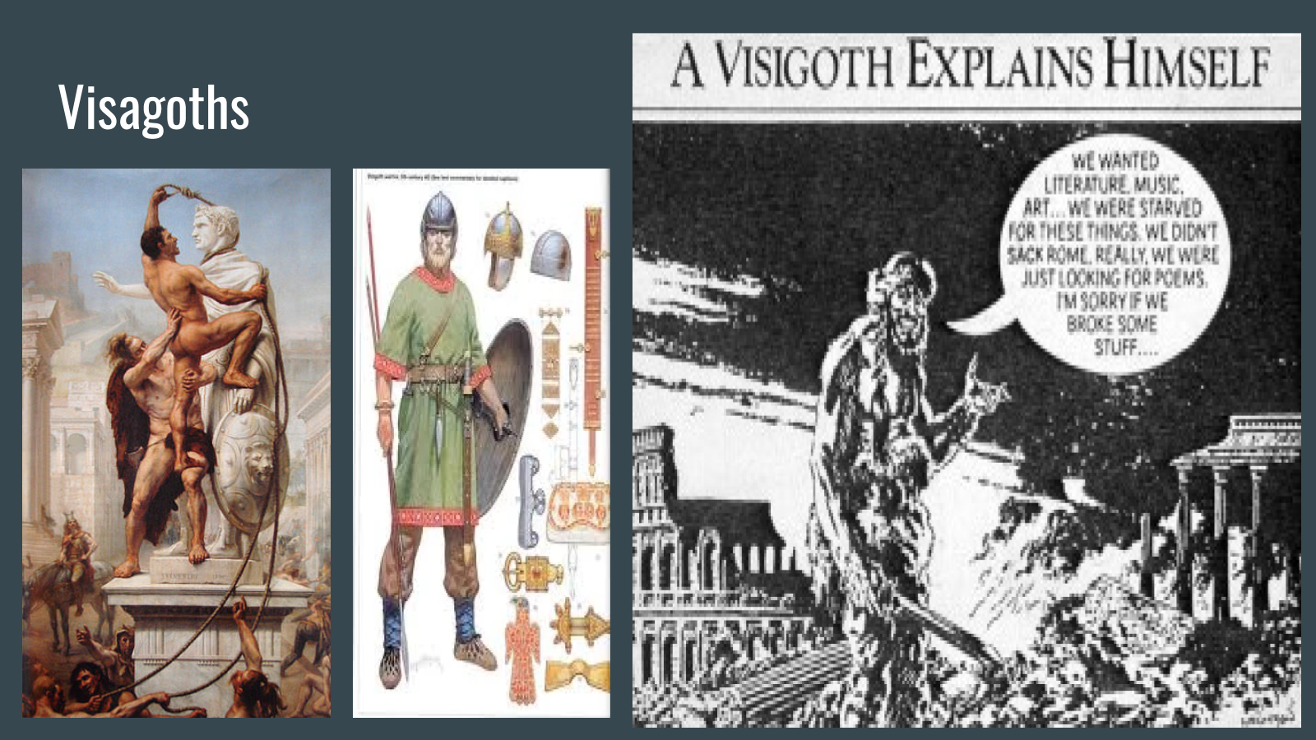

Use this space to take notes:

Slide 27 | Your Response
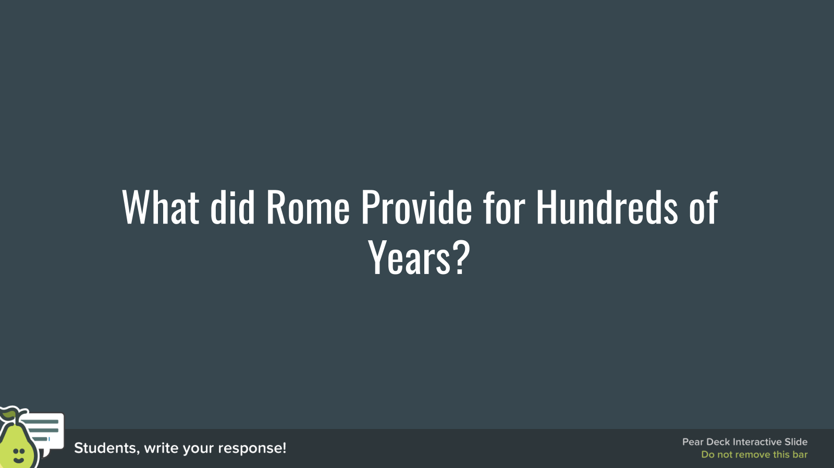
Use this space to take notes:

Slide 28
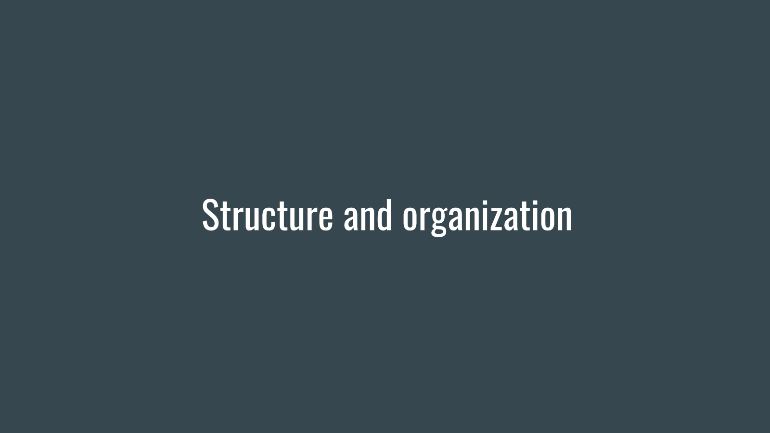

Use this space to take notes:

Slide 29
Use this space to take notes:

Slide 30
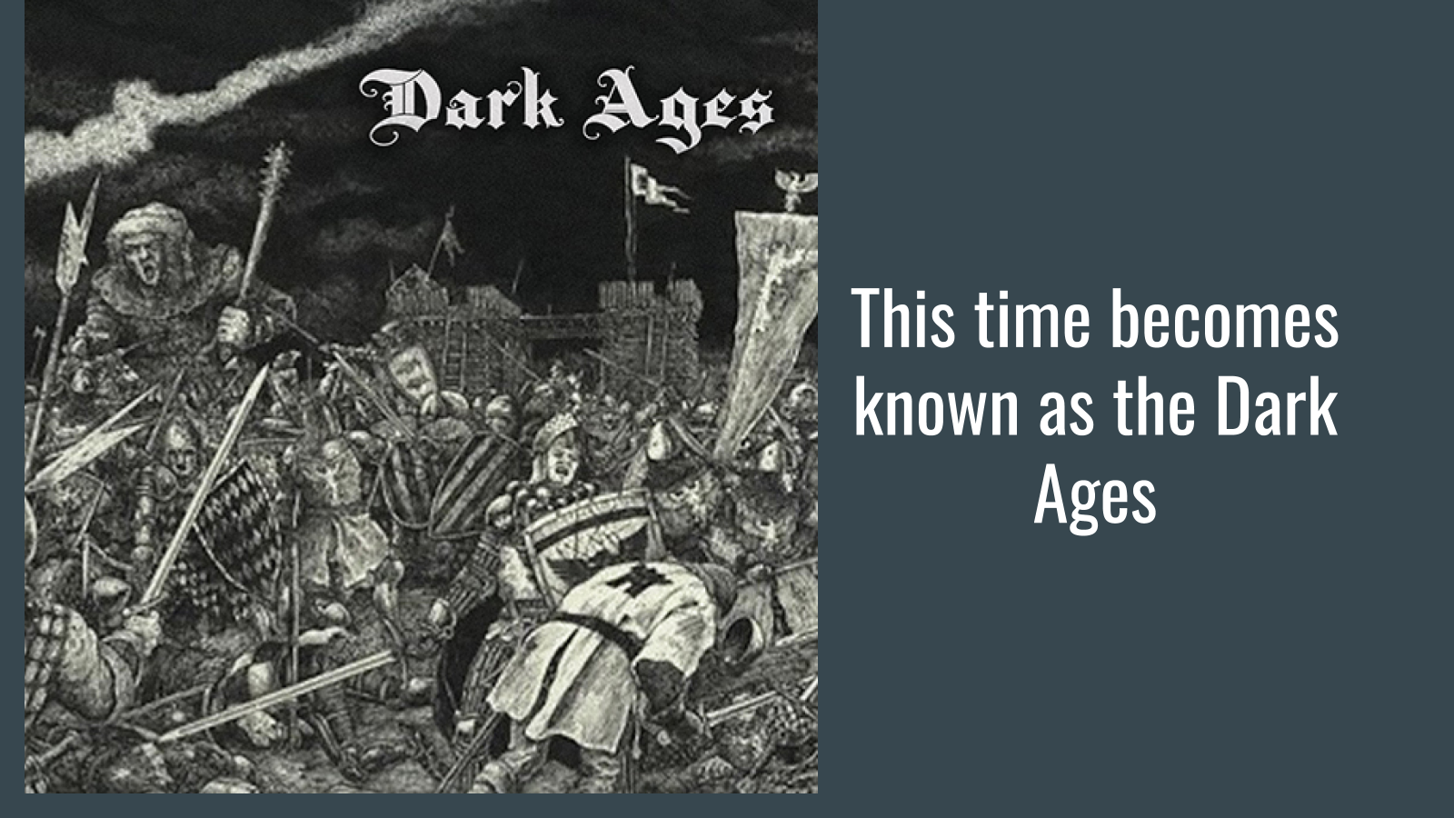

Use this space to take notes:

Slide 31
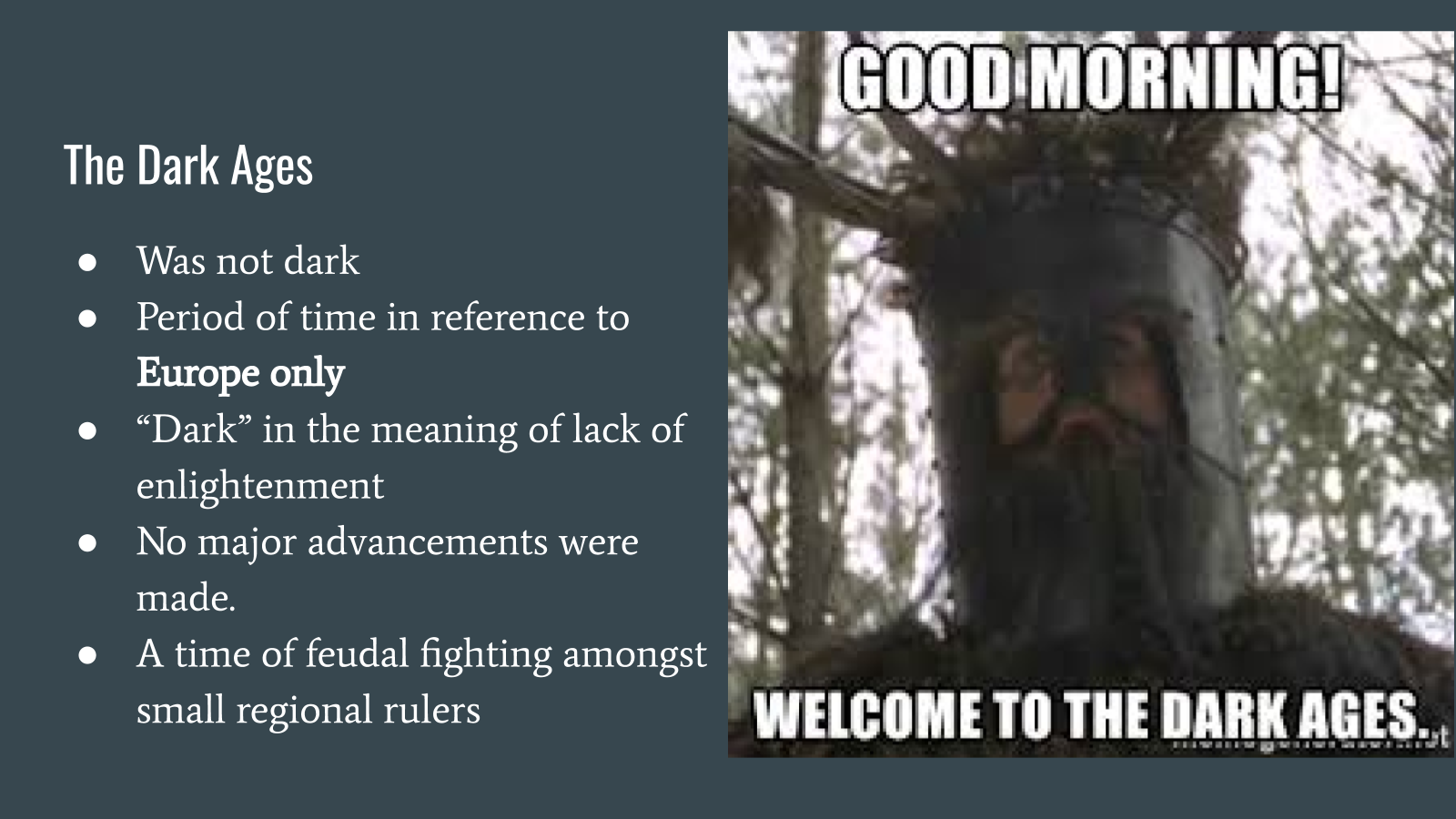

Use this space to take notes:

Slide 32
Use this space to take notes:

Slide 33
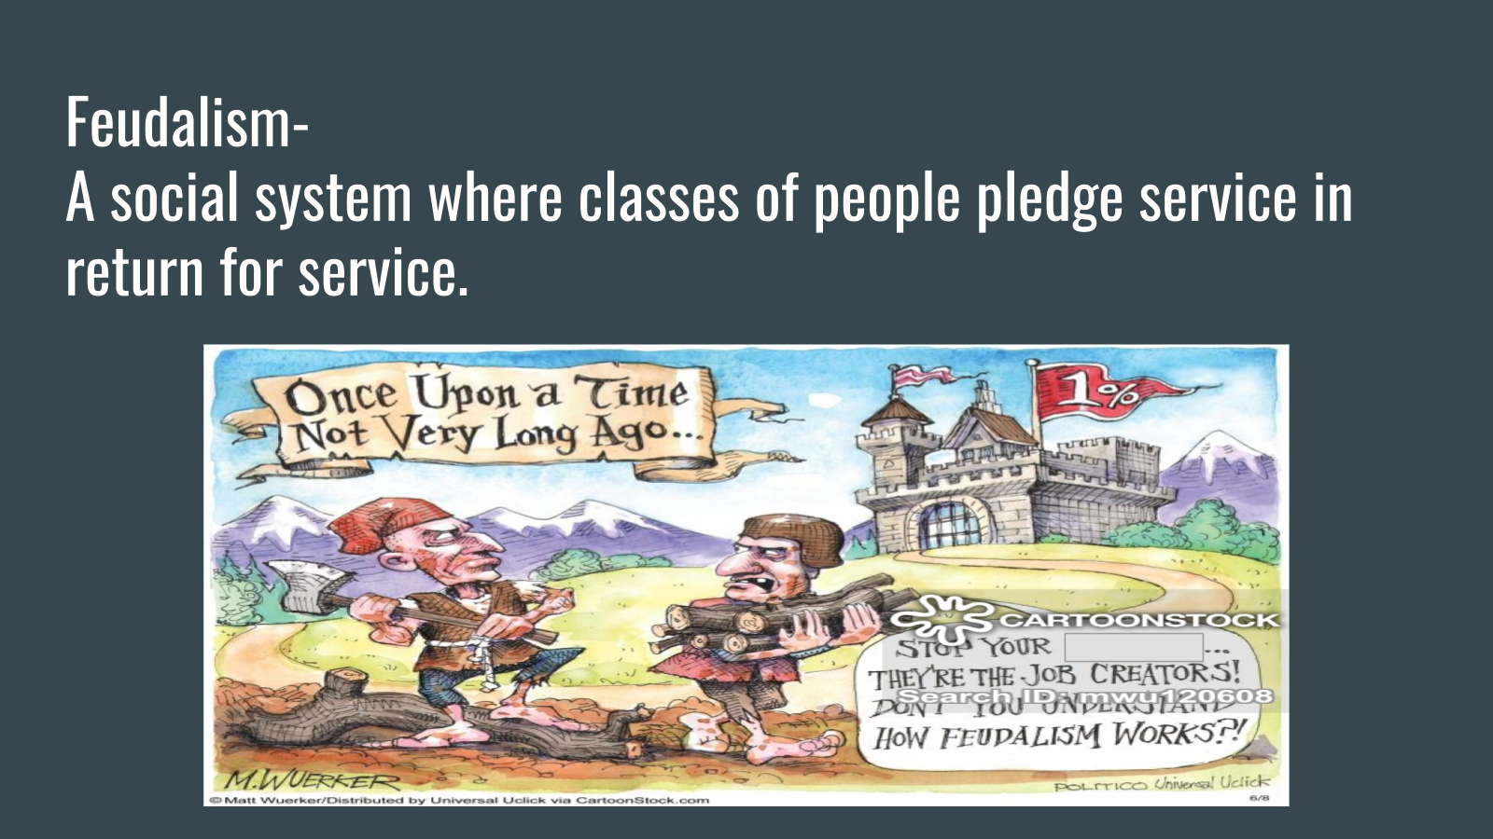

Use this space to take notes:

Slide 34
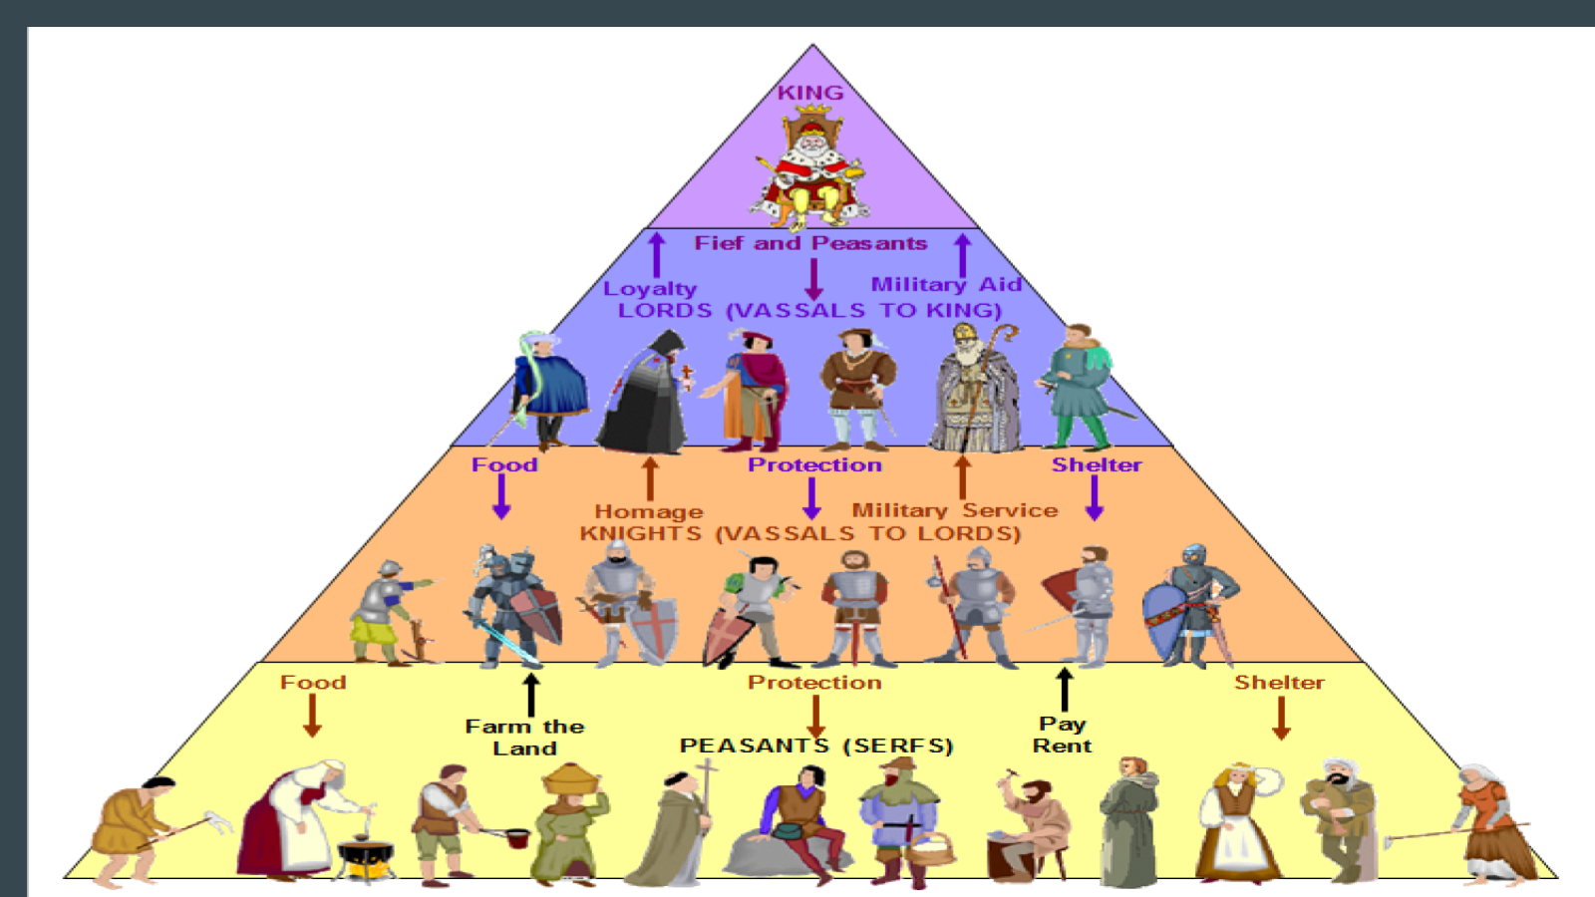

Use this space to take notes:

Slide 35
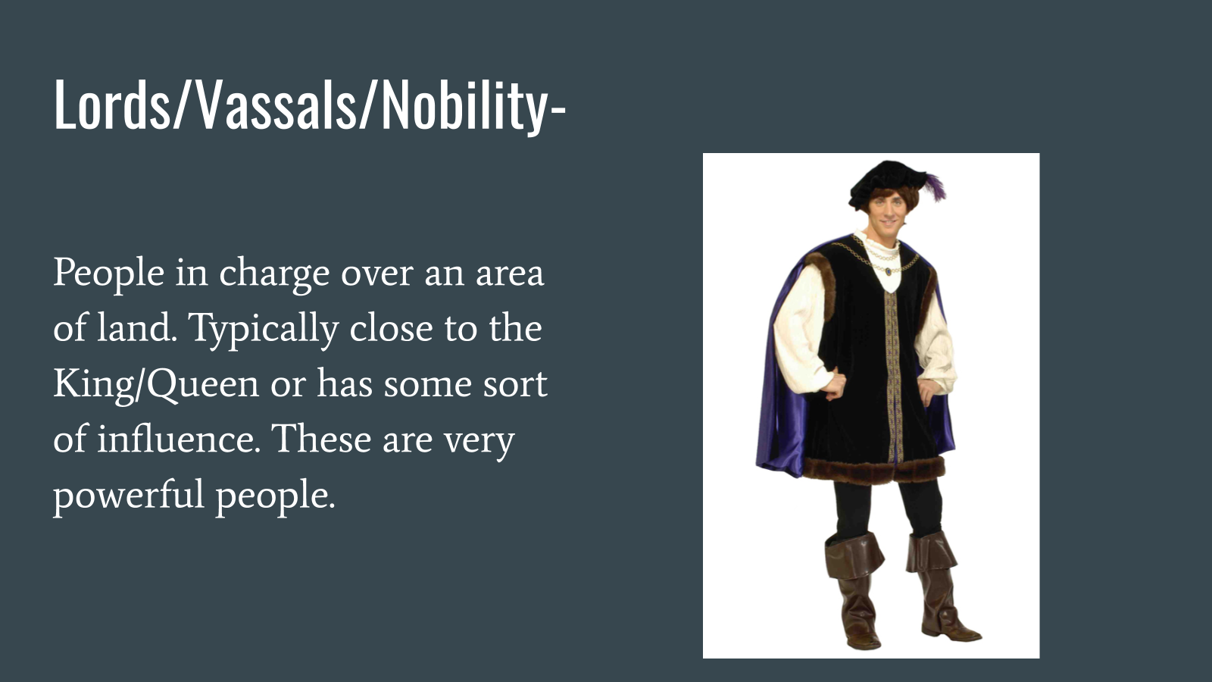

Use this space to take notes:

Slide 36
Use this space to take notes:

Slide 37
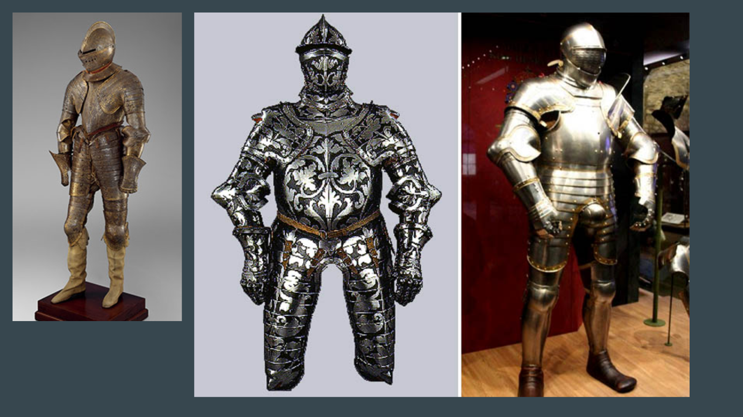

Use this space to take notes:

Slide 38

Link(s) on this slide:
- http://www.youtube.com/watch?v=pG0dMxybV_8

Use this space to take notes:

Slide 39
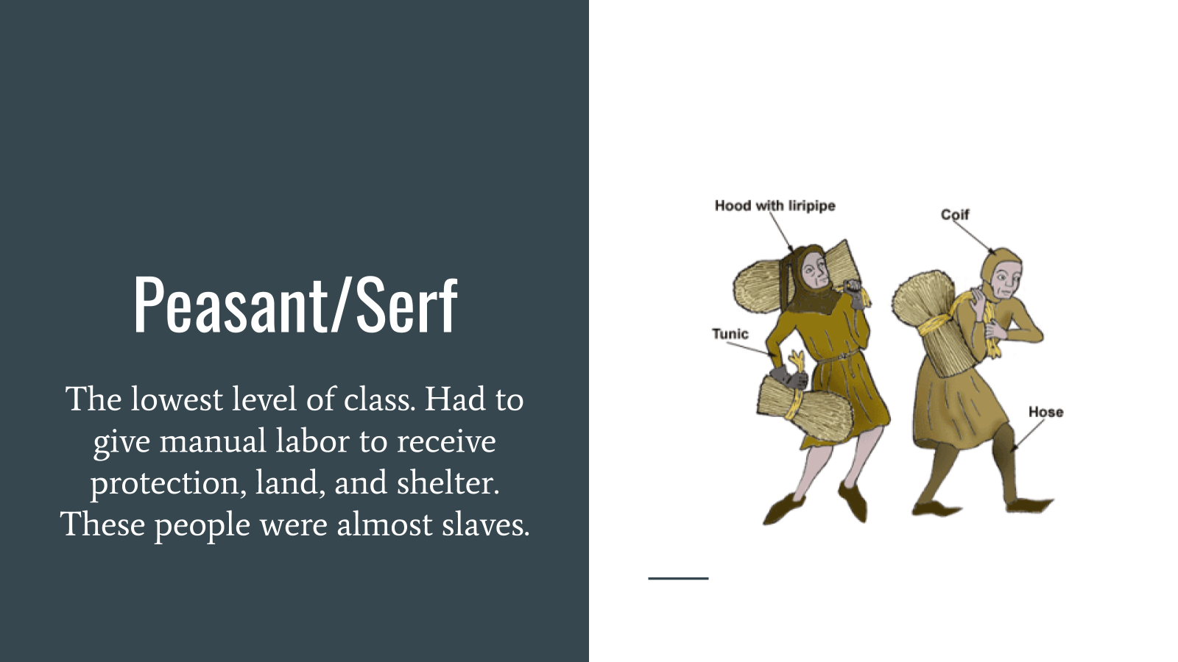

Use this space to take notes:

Slide 40

Link(s) on this slide:
- http://www.youtube.com/watch?v=TKu8Zlg8dtE

Use this space to take notes:

Slide 41
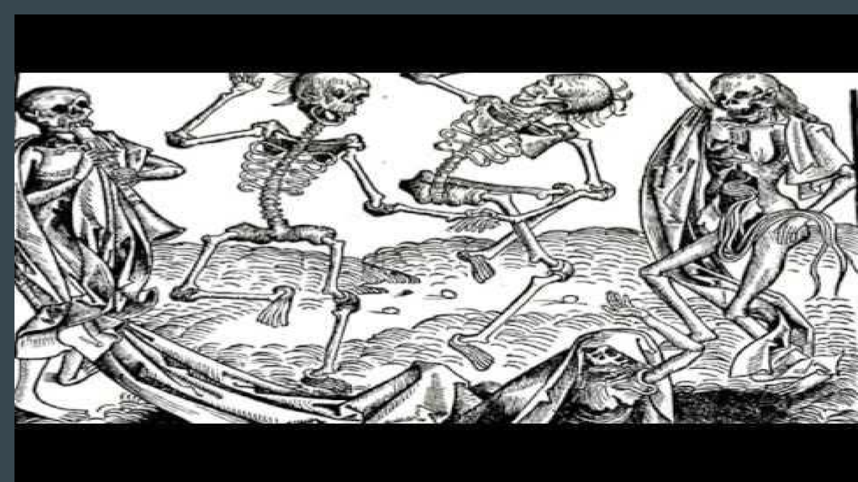

Link(s) on this slide:
- http://www.youtube.com/watch?v=Y0E62fiv6mk

Use this space to take notes:

Slide 42
Use this space to take notes:

