TEACHER REFERENCE DOCUMENT: A Short Summary of the Vietnam War
Imperialism and Colonialism
The Vietnam War has roots in Vietnam’s centuries of domination by imperial and colonial powers—first China, which ruled ancient Vietnam, and then France, which took control of Vietnam in the late 1800s and established French Indochina. In the early 1900s, nationalist movements emerged in Vietnam, demanding more self-governance and less French influence. The most prominent of these was led by Communist leader Ho Chi Minh, who founded a militant nationalist organization called the Viet Minh.
The First Indochina War
During World War II, when France was occupied by Nazi Germany, it lost its foothold in Vietnam, and Japan took control of the country. The Viet Minh resisted these Japanese oppressors and extended its power base throughout Vietnam. When Japan surrendered at the end of World War II in 1945, Ho Chi Minh’s forces took the capital of Hanoi and declared Vietnam to be an independent country, the Democratic Republic of Vietnam.
France refused to recognize Ho’s declaration and returned to Vietnam, driving Ho’s Communist forces into northern Vietnam. Ho appealed for aid from the United States, but because the United States was embroiled in the escalating Cold War with the Communist USSR, it distrusted Ho’s Communist leanings and aided the French instead. Fighting between Ho’s forces and the French continued in this First Indochina War until 1954, when a humiliating defeat at Dien Bien Phu prompted France to seek a peace settlement.
Divided Vietnam The Geneva Accords of 1954 declared a cease-fire and divided Vietnam officially into North Vietnam (under Ho and his Communist forces) and South Vietnam (under a French-backed emperor). The dividing line was set at the 17th parallel and was surrounded by a demilitarized zone, or DMZ. The Geneva Accords stipulated that the divide was temporary and that Vietnam was to be reunified under free elections to be held in 1956.
The Cold War and the Domino Theory
At this point, the United States’ Cold War foreign policy began to play a major part in Vietnam. U.S. policy at the time was dominated by the domino theory, which believed that the “fall” of North Vietnam to Communism might trigger all of Southeast Asia to fall, setting off a sort of Communist chain reaction. Within a year of the Geneva Accords, the United States therefore began to offer support to the anti-Communist politician Ngo Dinh Diem. With U.S. assistance, Diem took control of the South Vietnamese government in 1955 and declared the Republic of Vietnam. Due to the popularity of Ho Chi Minh throughout Vietnam, Diem promptly canceled the elections that had been scheduled for 1956.
The Diem Regime
Diem’s regime proved corrupt, oppressive, and extremely unpopular. He was so unpopular that some Buddhist monks protested his regime using self-immolation – setting oneself on fire. Nonetheless, the United States continued to prop Diem up, fearful of the increasing Communist resistance activity in South Vietnam. This resistance against Diem’s regime was organized by the Ho Chi Minh–backed National Liberation Front, which became more commonly known as the Viet Cong.
In 1962, U.S. president John F. Kennedy sent American “military advisors” to Vietnam to help train the South Vietnamese army, the ARVN, but quickly realized that the Diem regime
NC Civic Education Consortium 6 Visit our Database of K-12 Resources at http://database.civics.unc.edu/
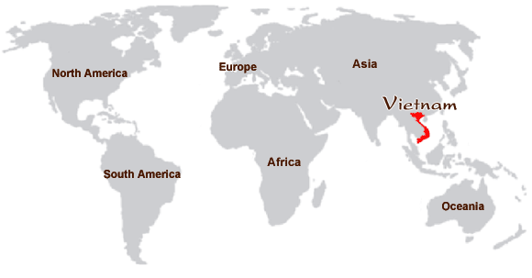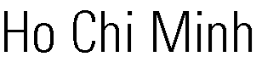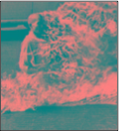
–
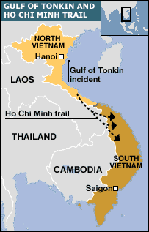
was unsalvageable. Therefore, in 1963, the United States backed a coup that overthrew Diem and installed a new leader. The new U.S.-backed leaders proved just as corrupt and ineffective.
Johnson and U.S. Escalation Kennedy’s successor, Lyndon B. Johnson, pledged to honor Kennedy’s commitments but hoped to keep U.S. involvement in Vietnam to a minimum. He kept Kennedy’s Secretary of Defense, Robert McNamara, but replaced the previous American military commander with William C. Westmoreland – a U.S. general who advocated aggressive strategies against Viet Cong and NVA using large numbers of U.S. forces. After North Vietnamese forces allegedly attacked U.S. Navy ships during the Gulf of Tonkin Incident in 1964, Johnson was given carte blanche in the form of the Gulf of Tonkin Resolution. This resolution allowed
Johnson “to take all necessary measure to repel any armed attack against the forces of United States and to prevent further aggression;” this greatly expanded his presidential power. With the free hand recently provided by Congress, Johnson ordered the U.S. Air Force and U.S. Navy to begin an intense series of air strikes called Operation Rolling Thunder. He hoped that the bombing campaign would demonstrate to the South Vietnamese the U.S. commitment to their cause and its resolve to halt the spread of Communism. Ironically, the air raids seemed only to increase the number of Viet Cong and NVA (North Vietnamese Army) attacks. Johnson’s “Americanization” of the war led to a presence of nearly 400,000 U.S. troops in Vietnam by the end of 1966.
Quagmire and Attrition In 1965, Westmoreland began to implement a search-and-destroy strategy that sent U.S. troops out into the field to find and kill Viet Cong members. Westmoreland was confident that American technology would succeed in slowly wearing down the Viet Cong through a war of attrition—a strategy of extended combat meant to inflict so many casualties on the enemy that it could no longer continue. U.S. leaders agreed, believing that North Vietnam’s economy could not sustain a prolonged war effort. In light of this new strategy of fighting a war of attrition, U.S. commanders were instructed to begin keeping body counts of enemy soldiers killed. Although body counts were indeed tallied, they were often exaggerated and proved wildly inaccurate, as the bodies of Viet Cong soldiers often were difficult to distinguish from the bodies of friendly South Vietnamese soldiers.
However, the Viet Cong’s guerrilla tactics frustrated and demoralized U.S. troops, while its dispersed, largely rural presence left American bomber planes with few targets. The United States therefore used unconventional weapons such as napalm – a highly flammable jellied substance -- and the herbicide defoliant Agent Orange but still managed to make little headway.
The Ho Chi Minh Trail
Meanwhile, U.S. forces continued to try to cut off Viet Cong supply lines through air power. These efforts expended a great deal of time and resources, but the North Vietnamese government proved extremely savvy in its ability to keep the Viet Cong supplied. Rather than attempt to send materials across the heavily guarded DMZ (the demilitarized zone surrounding the border between North and South Vietnam at the 17th parallel), they sent supplies via the Ho Chi Minh Trail, which ran from North Vietnam through Laos and Cambodia into South Vietnam (see map above). Troops and supplies streamed into South Vietnam via the trail and despite intense U.S. bombing throughout 1965, the trail never closed once, not even temporarily.
The “Credibility Gap”
Despite the numerous setbacks, Johnson and other U.S. officials, citing increased troop numbers and redefined objectives, again claimed to be making headway in the war. Many government officials reported that the North Vietnamese were declining in strength and were on the brink of defeat. Photos and video footage of dead American soldiers in newspapers and on evening news programs, however, indicated otherwise. Moreover, U.S. spending in support of the war had reached record levels, costing the government an estimated $3 billion a month. As a result, many people in the United States began to speak of a “credibility gap” between what Johnson and the U.S. government was telling the American people and what actually was transpiring on the ground.
NC Civic Education Consortium 7 Visit our Database of K-12 Resources at http://database.civics.unc.edu/
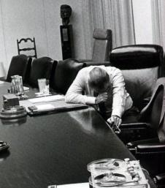
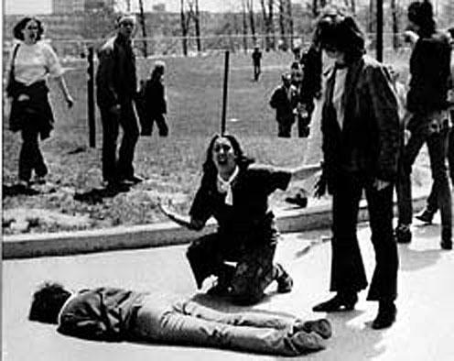
The Tet Offensive
In 1968, the North Vietnamese Army and the Viet Cong launched a massive campaign called the Tet Offensive, attacking nearly thirty U.S. targets and dozens of other cities in South Vietnam at once. Although the United States pushed back the offensive and won a tactical victory, American media coverage characterized the conflict as a defeat, and U.S. public support for the war plummeted. Morale among U.S. troops also hit an all-time low, manifesting itself tragically in the 1968 My Lai Massacre, in which frustrated U.S. soldiers killed hundreds of unarmed Vietnamese civilians in a small village.
The Antiwar Movement
Meanwhile, the antiwar movement within the United States gained momentum as student protesters, countercultural hippies, and even many mainstream Americans denounced the war. Protests against the war and the selective service system -- military draft -- grew increasingly violent, resulting in police brutality outside the Democratic National Convention in 1968 and the deaths of four students at Kent State University in 1970 when Ohio National Guardsmen fired on a crowd. Despite the protests, Johnson’s successor elected in 1968, President Richard M. Nixon, declared that a “silent majority” of Americans still supported the war.
Vietnamization and U.S. Withdrawal Nonetheless, Nixon promoted a policy of Vietnamization of the war, promising to withdraw U.S. troops gradually and hand over management of the war effort to the South Vietnamese. Although Nixon made good on his promise, he also illegally expanded the geographic scope of the war by authorizing the bombing of Viet Cong sites in the neutral nations of Cambodia and Laos, all without the knowledge or consent of the U.S. Congress. The revelation of these illegal actions, along with the publication of the secret Pentagon Papers in US newspapers in 1971, caused an enormous scandal in the United States and forced Nixon to push for a peace settlement. These papers revealed that the U.S. Army, as well as presidents Truman, Eisenhower, Kennedy, and Johnson, had authorized a number of covert actions that increased U.S. involvement in Vietnam unbeknownst to the American public. The government tried to block the publication of these papers under the guise of “national security”, but the Supreme Court ruled in New York Times v. US that the government must prove an immediate threat to national security to censure the papers.
Congress’s Response
Outraged by the unauthorized invasion of Cambodia and by the double scandal from the My Lai Massacre and the Pentagon Papers, many in Congress took steps to exert more control over the war and to appease the equally angry public. The Senate voted to repeal the Gulf of Tonkin Resolution to reduce the military’s unchecked spending power (although the House of Representatives did not follow suit). Congress also reduced the number of years drafted soldiers needed to serve in the army. Finally, the Twenty-Sixth Amendment was ratified in 1971 to lower the U.S. voting age from twenty-one to eighteen, on the grounds that the young men serving in Vietnam should have a say in which politicians were running the war.
The War Powers Resolution
In July 1973, Congress and the American public learned the full extent of the secret U.S. military campaigns in Cambodia. Testimony in congressional hearings revealed that Nixon and the military had been secretly bombing Cambodia heavily since 1969, even though the president and Joint Chiefs of Staff had repeatedly denied the charge. When the news broke, Nixon switched tactics and began bombing Cambodia openly despite extreme public disproval.
Angry, Congress mustered enough votes to pass the November 1973 War Powers Resolution over Nixon’s veto. The resolution restricted presidential powers during wartime by requiring the president to notify Congress
NC Civic Education Consortium 8 Visit our Database of K-12 Resources at http://database.civics.unc.edu/
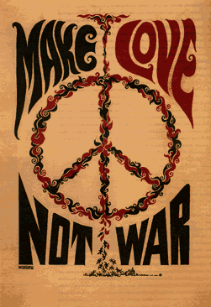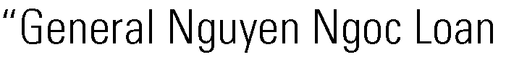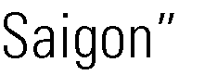
upon launching any U.S. military action abroad. If Congress did not approve of the action, it would have to conclude within sixty to ninety days. In effect, this act made the president accountable to Congress for his actions abroad. Congress also ended the draft in 1973 and stipulated that the military henceforth consist solely of paid volunteers. Both the War Powers Resolution and the conversion to an all-volunteer army helped quiet antiwar protesters.
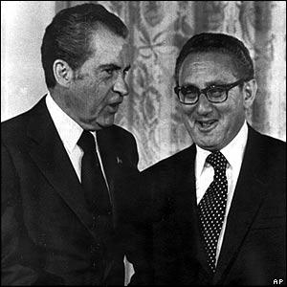
Nixon and Kissinger
The Cease-fire and the Fall of Saigon After secret negotiations between U.S. emissary Henry A. Kissinger and North Vietnamese representative Le Duc Tho in 1972, Nixon engaged in diplomatic maneuvering with China and the USSR—and stepped up bombing of North Vietnam—to pressure the North Vietnamese into a settlement. The Paris Peace Accords were finally signed in January 1973, and the last U.S. military personnel left Vietnam in March 1973.
Under the terms of the agreement, Nixon pledged to withdraw all remaining military personnel from Vietnam and allow the tens of thousands of NVA troops in South Vietnam to remain there, despite the fact that they controlled a quarter of South Vietnamese territory. However, Nixon
promised to intervene if North Vietnam moved against the South. In exchange, North Vietnam promised that elections would be held to determine the fate of the entire country. Although Nixon insisted that the agreement brought “peace with honor,” South Vietnamese leaders complained that the terms amounted to little more than a surrender for South Vietnam.
The U.S. government continued to fund the South Vietnamese army, but this funding quickly dwindled. Meanwhile, as President Nixon became embroiled in the Watergate scandal that led to his resignation in August 1974, North Vietnamese forces stepped up their attacks on the South and finally launched an all-out offensive in the spring of 1975. On April 30, 1975, the South Vietnamese capital of Saigon fell to the North Vietnamese, who reunited the country under Communist rule as the Socialist Republic of Vietnam, ending the Vietnam War.
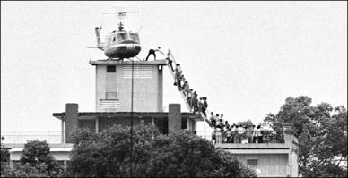
Adapted and Edited by the North Carolina Civic Education Consortium Sources: http://www.sparknotes.com/history/american/vietnamwar/summary.html http://www.vn-tours.com/images/tour/map/vietnam-asia-map.gif http://img.timeinc.net/time/time100/images/main_hochiminh.jpg http://scrapetv.com/News/News%20Pages/usa/images-3/vietnam-war-monk-self- immolation.jpg http://news.bbc.co.uk/nol/shared/spl/hi/asia_pac/05/vietnam_war/img/maps/2.gif http://lefteyeonthemedia.files.wordpress.com/2008/12/lbj_regretting_vnw.jpg
http://upload.wikimedia.org/wikipedia/en/f/f9/Nguyen.jpg http://www.bristol.ac.uk/Depts/History/Sixties/Feminism/1968_files/image001.gif http://www.uiowa.edu/~policult/assets/VietNam/KentState.jpg http://news.bbc.co.uk/media/images/40336000/jpg/_40336701_nixon_and_kissinger300.jpg https://wikis.nyu.edu/ek6/modernamerica/uploads/Imperialism.ColdWarContainment/Evacuati on.gif
NC Civic Education Consortium 9 Visit our Database of K-12 Resources at http://database.civics.unc.edu/
Evacuating civilians after the fall of Saigon
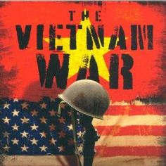
Name _____________________________________
Student Notes: A Short Summary of the Vietnam War
- Why was Ho Chi Minh fighting the French? What was the name of his organization?
- What happened at Dien Bien Phu?
- How did the United States’ foreign policy relate to an increased presence in Vietnam?
- What group organized resistance to Diem’s regime? List both names for the organization.
- What was the Gulf of Tonkin resolution? Why was it passed? Why is it significant?
- What was the purpose of Operation Rolling Thunder? Did it work?
- What strategies did the United States use in Vietnam? Why did they believe they would work?
- Why was the Ho Chi Minh Trail significant?
- What was the Tet Offensive? How is it related to the Creditability Gap?
- What was Vietnamization?

